MUTALE MUNICIPALITY



DRAFT IDP DOCUMENT (MARCH 2007)

TABLE OF CONTENT

ITEM | PAGE NO
A. PHASE 1: ANALYSIS  1. Analysis  2. Background  3 Analysis of priority issues  4. Social development  5. Economic Development  7. Governance and Administration  B. PHASE 2  - Strategies  - PHASE 3: PROJECTS  - ELECTRICITY PROJECTS  - SANITATION  - WATER  - PUBLIC WORKS FUNDING ON ROADS AND BRIDGES  - MIG OWN FUNDING ON ROADS AND BRIDGES  - MIG OWN FUNDING ON BUILDING  - RAL PROJECT  - PHASE 4: INTERGRATION (ANNEXURES)  - ANNEXURE A: WASTE MANAGEMENT  - ANNEXURE B: DISATER MANAGEMENT PLAN  - ANNEXURE C: COMMUNICATION STRATEGY  4. ANNEXURE D: S D F | 3  3-7  7  7-14  14-18  18-19  19-20  20-24  24  24 -29  29-30  31-35  36-37  48-39  40-41  42-43  44 - 56  57- 59  60 -81  82 - 130

PHASES 1

1. ANALYSIS

1.1 INTRODUCTION
During the Analysis phase the process focused only on the relevant aspects of issues influencing the development of the municipality. The purpose of this phase was also then to ensure that decisions on strategies and projects will be based on:
- the qualitative priority needs and challenges on local residents,
- proper quantitative information on all those priority issues,
- clear knowledge of the availability of local resources, and
- A holistic understanding of the dynamics or key issues determining the various development priorities within the municipality.

2. BACKGROUND

2.1 LOCATION

Mutale Local Municipality is one of the four local municipalities comprising Vhembe District Municipality. It is situated in the far north eastern corner of the District. It serves a population of 131 781 (municipal IDP) spread over 150 villages. The total land cover of the Municipality is 2375, 78212 Hectares. The Kruger National Park forms the eastern boundary of Mutale Local Municipality, with the great Limpopo River forming the north-eastern boundary. The Municipality’s strategic location affords it many opportunities for tourism development.

Mutale Local Municipality shares borders with Musina Local Municipality and the Republic of Zimbabwe on the North, the Republic of Mozambique on the East, Makhado Local Municipality to the west and Thulamela Local Municipality to the south. The Municipality is accessed through R525 linking the Kruger National Park to other local municipalities within Vhembe District. It can also be accessed through P277/1 linking Thohoyandou and Mutale.

2.2. DEMOGRAPHICS.

WARD | POPULATION  2005. | POPULATION  2006. | NO.OF H/ HOLDS
01. | 9827 | 18605 | 2142
02. | 7712 | 8649 | 1727
03. | 9175 | 9215 | 1821
04. | 7091 | 11808 | 2734
05. | 6111 | 12611 | 3152
06. | 11573 | 5607 | 1491
07. | 8584 | 16350 | 2775
08. | 12109 | 16759 | 2671
09. | 7513 | 10545 | 2022
10. | 9830 | 12117 | 2028
11. | 6187 | 9515 | 1906
TOTAL | 95712 | 131781 | 24469

2.3 REGISTERED VOTERS PER WARD.

WARDS | REGISTERED VOTERS | % of registered voters
WARD 1 | 4205 | 10.74%
WARD 2 | 3111 | 7.94%
WARD 3 | 3461 | 8.84%
WARD 4 | 3634 | 9.28%
WARD 5 | 3440 | 8.78%
WARD 6 | 3879 | 9.90%
WARD 7 | 3333 | 8.5%
WARD 8 | 4099 | 10.47%
WARD 9 | 3355 | 8.5%
WARD 10 | 3345 | 8.5%
WARD 11 | 3285 | 8.39%
TOTAL | 39147 | 100%

2.4. ACCESS TO MUNICIPAL SERVICES
The total number of households within the Municipality area is 24 469 . Service Levels are as per the table below.
SERVICE | 2001 (17 645 HOUSEHOLDS) | 2005 (20 795 HOUSEHOLDS) | 2006 (24 469 households
 | Basic and above Below basic | Access (RDP No access (below RDP  Standard) standard) | Basic and above Below basic
Water | 13 796 3 849 | 4 343 16 452 | 6 611 17 858
Sanitation | 9 831 7 814 | 3 683 17 212 | 6 392 18 107
Electricity | 7 280 10 365 | 9 574 11 221 | 13 703 10 766
Refuse Removal | 1 067 16 578 | 900 19 895 | 1 224 23 245
Housing | 9 447 8 198 | 12 865 7 930 | 15 171 9 298
Telephone | 12 108 5 537 | 6 595 14 200 | 7 586 16 883

Current service delivery backlogs
Sanitation : 74%
Water : 73%
Electricity : 44%
Refuse removal : 95%
Housing : 38%
Telecommunication : 69%

2.5. Population receiving Free Basic Services
FBS | Total households | Total indigent households | Household/Indigent served | % Served
FBW | 24 469 | 14 262 | 14 262 | 58%

FBS |  | Households  R800 and less monthly income | TOTAL HOUSEHOLDS RECEIVING FREE BASIC ELECTRICITY | BUDGET ALLOCATION (2004/05) |  | TOTAL EXPENDITURE (2005/06)
FBE |  | 9 574 | 1205 | R 874 552 00 |  | 146 526
FBS | POPULATION  2001 |  | GENERATED WASTE 2004 (TONS) |  | % POPULATION RECEIVING SERVICE | %POPULATION NOT RECEIVING
FBR | 78922 |  | 2500 |  | 7% | 93%

  - MUNICIPAL WIDE PRIORITY ISSUES

1 | WATER & SANITATION
2 | ELECTRICITY AND STREETS LIGHTS
3 | HOUSING AND LAND
4 | ROADS AND STORMWATER DRAINAGE
5 | WASTE MANAGEMENT
6 | FINANCIAL VIABILITY
7 | MUNICIPAL TRANSFORMATION
8 | GOOD GOVERNANCE
9 | AGRICULTURAL DEVELOPMENT
10 | TOURISM
11 | INDUSTRIES AND SKILLS DEVELOPMENT
12 | SPORT AND RECREATION
13 | MINING
14 | SMME SUPPORT & TRADE PROMOTION
15 | EDUCATION AND TRAINING
16 | HEALTH AND SOCIAL DEVELOPMENT
17 | TELECOMMUNICATION
18 | SAFETY AND SECURITY

- ANALYSIS OF PRIORITY ISSUES.

These priority needs, together with the core operational and management functions (requirements) form the basis of the IDP process and assisted the Representative Forum in Identifying the important development priorities to be addressed during the next five years.
The dynamics underlying each of these priority issues will be discussed acccording to this discussion framework in more detail
below.
ECONOMIC DEVELOPMENT
Agricultural development
Tourism
Industries & Skills Development
Mining
SMME support & Trade Development

GORVENANCE AND ADMINISTRATION

Financial Viability
Municipal Transformation
Good Governance

SOCIAL DEVELOPMENT
Water &
Electricity and Lights
Housing and Land
Roads Sanitation & Storm water drainage
Waste Management
Health & Welfare
Education and training
Safety & Security
Sports & Recreation

3.1. SOCIAL DEVELOPMENT.

3.1.1 Water

Approximately 73% of the population does not have access to clean potable water.
While it appears that a large percentage of households have access to sources of water, it cannot be confirmed that these households have access “to a secure source of water for human consumption”. Many people have to travel a distance to collect water from a public tap
The rural areas mostly make use of fountains and boreholes as their water source as there are, in many cases, difficulties experienced with water supply from farm owners. In some cases surrounding farm workers even collect water from communal stands in nearby urban areas.

Core issues

The underlying causes of the abovementioned realities as well as the resulting core issues that need to be addressed are summarized in the table below:

CORE ISSUE | DESCRIPTION
Water losses | Water is lost from the network annually due to illegal connections, wastage and leakages. These losses could be reduced by proper metering and leakage repair, resulting in accountable water and financial savings.
Maintenance and upgrading of equipment | Maintenance and upgrading of equipment will facilitate the constant and uninterrupted provision of water services. Proper equipment will also ensure a long term cost saving through maintenance rather than constant replacement.
Management of Capital projects | Although the municipality does not have the capacity to design and manage large capital projects yet, constant effort should be made to increase internal capacity to monitor and manage such projects to ensure compliance with internal planning and constantly becoming less dependent.

3.1.2 Sanitation

In general the provision of sanitation services bulk sanitation in all the urban areas is inadequate and not up to the minimum standard as required by law. Approximately 74% of the population does not have access to proper sanitation.

Core issues

The underlying causes of the abovementioned realities as well as the resulting core issues that need to be addressed are summarized in the table below:

CORE ISSUES | DESCRIPTION
Upgrading sub standard services | The continuous provision of suitable sanitation services to all unserviced erven is the most direct activity in addressing current backlogs.
Rural sanitation provision | Efforts will have to be made to include rural areas within the projects and budget of the municipality, referring to the provision of services. Pit Latrines are recommended for those areas
Capacitated personnel | None of the town units within the municipality has sufficient technical and human resources to be able to upgrade and maintain the sanitation infrastructure beyond basic repairs. Organizational structures should include sufficient technical  personnel as far as possible.
Maintenance and upgrading of network and equipment | Maintenance and upgrading of equipment will facilitate the constant and uninterrupted provision of sanitation services. Proper equipment will also ensure a long-term cost saving through maintenance rather than constant replacement.

3.1.3 Electricity and Street Lights

Eskom distributes electricity throughout the region.

Within the rural areas only an estimated 66 % have electricity connections to their houses. The communities have identified areas, which are in need of electricity

Core issues

The underlying causes of the abovementioned realities as well as the resulting core issues that need to be addressed, are summarized in the table below:

CORE ISSUES | DESCRIPTION
Clusters of erven without electricity. | The clusters of households in the various towns that are not connected to the electricity network should receive attention. These households should be connected to the network as soon as possible to provide equality of services to all.
Absence of area lighting in all areas. | The lack of area lighting in all areas makes nightlife dangerous and difficult. Crime is more evident in these areas and especially women and children are vulnerable in these situations.

3.1.4 Roads and Storm water

Important routes for economic and tourism has been identified for development. These are Shadani, Masisi, Matavhela-Muswodi, Folovhodwe, Tshipise and Tshandama- Matavhela via Tshixwadza.

Overall, the roads within the jurisdiction area of the municipality are in a poor condition and in dire need of upgrading. Apart from the main provincial and regional roads, most of the rural access routes are graveled and not being maintained properly. Within the urban areas, the main roads are old and deteriorating rapidly, whilst most of the distributor roads are graveled.
The biggest threat to road maintenance is the absence of proper bulk storm water drainage systems. The roads situation within Mutale is as follows:
The remainder of all the roads in Mutale as well as in Masisi, are dirt roads that are graded on a regular basis.

Core issues
The underlying causes of the abovementioned realities as well as the resulting core issues that need to be addressed are summarized in the table below:

CORE ISSUES | DESCRIPTION
Insufficient storm water in various areas. | The lack of storm water drainage contributes greatly to the poor state of roads. The provision of adequate storm water drainage will drastically limit the need for maintenance.
Weak condition of roads. | Roads are not maintained regularly with the result that the condition of poor roads deteriorate rapidly. Large trucks make use of many of the major roads.

3.1.5 Housing

Since the provision of housing does not fall under the core competency of the local municipality, the main focus is on the promotion of housing developments through assisting in the provision of erven, submission of applications and the control of beneficiaries. Approximately 38% of the population does not have access to proper RDP houses.
The majority of the residents live in traditional huts, which is, in terms of RDP standards, described as inadequate housing.

Core issue
The underlying causes of the abovementioned realities as well as the resulting core issues that need to be addressed are summarized in the table below:

CORE ISSUES | DESCRIPTION
Housing backlog. | Housing is a basic need and many of the people have insufficient housing. This backlog will have to be addressed to provide quality of life to these citizens.
Related services infrastructure requirements | Housing projects should not be seen in isolation and support service infrastructure will have to be supplied to areas earmarked for housing development. The subsequent costs and ability of the municipality to deliver such services should also be considered.

3.1.6 Cemeteries

The Municipality is sharing a burial site with the local (Phalama) village and the average number of burials per month is 3, as stipulated in the table below:
TOWN | No. of old Cemeteries, no longer in use | No. of current cemeteries in use | Pressure (No. of sites still available) | Average No. of burials per month
Mutale | 1 | 1 | 0 | 3
Masisi | 0 | 0 | 0 | 0
TOTAL | 1 | 1 | 0 | 3

3.1.7 Health

Emergency services associated with health care are given in the table below:

Municipality | Hospital | Health Clinics | Health Centre | HIV/Aids Desk | Mobile Clinics | Oral Health | Nutrition Program | Emergency Service | Radio  graphic Service
Mutale | 0 | 17 | 1 | 0 | 3 | 0 | y | 1 | 0

The main community needs are also summarized below:

    - Ambulance Services
Ambulance service serves a wide area within the region and the operating cost is escalating constantly.

    - Fire Fighting Service
Fire Fighting Service is rendered by the District Municipality. A proper fire station has been erected at Mutale by the District Municipality. Local residents have to be trained in fire fighting.
    - Hospital
Hospitals are located in Thulamela, which is 100km away from the residents. The services at the local health clinics are not up to standard. A fully equipped hospital is urgently needed in Mutale.

    - HIV/AIDS Desk
There is a significant increase in HIV/AIDS and TB occurrence. A counseling/help desk is needed in each clinic where the community can be guided and counseled
    - Malnutrition
Malnutrition occurs, especially among young children. Nutrition programs must be initiated by the municipality and the Dept of Health

4. EDUCATION

Education is a crucial part of higher provincial structures and the role of the municipality is only seen as one of supporting SGBs, liaising with the Department of Education, assisting in the provision of land and facilities and promoting regional policies aimed at maintaining a high quality of education of both the younger learners as well as adults and the labor market.

There are 83 Primary Schools and 27 Secondary schools in the Mutale area, which are predominantly government funded and operated.
There is no tertiary facility. Due to the agricultural characteristic of the area, as well as the lack of education facilities in the rural areas, the development of a quality agricultural school for the region should be investigated. The establishment of tertiary institution should also be investigated and facilitated.

ABET projects within the municipal area are non-functional, mainly because of budgetary constraints and lack of interest.

Core issues
The underlying causes of the abovementioned realities as well as the resulting core issues that need to be addressed are summarized in the table below:

CORE ISSUES | DESCRIPTION
Maintain high level of pass rate | All efforts should be made to maintain the increased level of pass rate at schools in the area.
Discipline of learners and educators. | Measures should be put in place to maintain the discipline Mechanisms should be considered to address discipline of both learners and educators.
Parent Involvement. Improve discipline. | Parent involvement in the education of their children, as well as the general management, maintenance and functioning of the school and its facilities should improve education standards.
Adult literacy. | High levels of adult illiteracy occur within the various areas of the community and this in return increases poverty and health risks due to ignorant residents. The local ABET programme will have to be expanded and promoted to address this issue.
Tertiary education opportunities. | The rural areas as well as smaller towns, do not have direct access to local tertiary satellite education services. This results in a rapid decline in the higher education levels within the area, as well as an outflow of youth seeking education opportunities in major centres. Local access to student loans, satellite services and information could remedy this situation.

5. PUBLIC SAFETY AND SECURITY

As would be expected in smaller towns, the general crime rate is lower than other urban nodes in the province

The ability to combat crime is hampered through a lack of proper communication, a lack of information from community members and under resourced police stations. It is believed that a greater community involvement through existing structures should address most of these problems.

Core issues

The underlying causes of the abovementioned realities as well as the resulting core issues that need to be addressed are summarized in the table below:

CORE ISSUES | DESCRIPTION
Community co-operation. | Intelligent policing is dependent on the input of the entire community in terms of both resources and basic information. Currently these efforts of community involvement are hampered by intimidation and the fact that all role players are not involved in a structured system. The Sectoral Policing Forum will address these problems.
Capacity of local stations. Distances | The capacity of the SAPS stations is limited due to a lack of proper equipment and vehicles and sufficient numbers of police officers. This problem is caused by a lack of financial resources.

6. SPORTS AMD RECREATION

The area lacks adequate Sports and Recreational facilities. There is only two Community Halls, situated in Mutale and Masisi which must cater for all residents. There are mostly inadequate grounds to use for soccer fields throughout the municipal area. The youth are generally not exposed to other sporting codes.

7. ECONOMIC DEVELOPMENT

7.1 Agricultural Development

Extensive farming (crop and livestock) is more prevalent in the eastern areas.

Core issues
The underlying causes of agricultural development realities as well as the resulting core issues that need to be addressed are summarized in the table below:

CORE ISSUES | DESCRIPTION
Very little value adding taking place. | The fact that very limited value adding is taking place places a large burden on the agricultural sector and makes the region very vulnerable to factors influencing agriculture. Many of these factors cannot be controlled such as the weather and prices. To limit the vulnerability to markets it is important to add value to products before it is exported out of the municipality.
Good agriculture potential. | The area has proven that it has good agricultural potential. This should be exploited, but as mentioned above the necessary supporting sectors will have to be developed before the agricultural sector can expand.
Role of emerging farmers. | Emerging farmers need support from existing commercial farmers and the Department of Agriculture in terms of knowledge and information sharing. The agricultural sector should be made more accessible to emerging farmers.

7.2 Tourism Development

The table below provides a brief overview of tourist attractions and facilities within the area of jurisdiction of Mutale.

Tourist Attraction | Location | Exclusiveness
Baobab Tree | Zwigodini Village | Biggest tree in Africa
Domboni Caves | Domboni Village | Hiding place during Tribal wars
Sagole Spa | Tshipise | Warm baths and accommodation
Nwanedi Nature Reserve | Folovhodwe | Animal viewing & accommodation
Makuya Park | Adjacent to Kruger National Park | Animal viewing & camping facilities
Tshavhadinda Cave | Ha-Rambuda | Hiding place during Tribal wars
Tourist Attraction | Location | Exclusiveness
Awelani | Tshikuyu | Caves
Dzhinzhikoni | Dzamba | Potholes
Dalavhuredzi Water falls | Mufulwi | Ancient finger prints
Khwanda dza Mbidi cultural village | Pile | Traditional houses arts & culture
Tshathanga Caves | Maramanzhi | Hiding place during tribal wars
Mutavhatsindi Nature reserve | Thengwe | Miracle tree
Gundani Mutsiwa Camp site | Gundani | Mutsiwa tree and bird viewing
Mutale water falls | Makuya park | Makuya park
Tshiungani Ruins | Tshiungani | Hiding place during tribal wars
Gogogo parks | Gogogo | Cultural village
Tshandama arts | Tshandama | Tourism and Information center
Phafuri cultural village | Bennde Mutale | Cultural villages
Mangwele cave | Mangwele Village | Cave

These natural wonders are however not easily accessible due to the poor road infrastructure of the Municipality. A lack of reliable energy and potable water also hinder the growth of the tourism industry. No database of all tourism centers exist, resulting in these centers not properly developed and marketed

Core issues

The underlying causes of the abovementioned realities as well as the resulting core issues that need to be addressed are summarized in the table below:
CORE ISSUES | DESCRIPTION
Co-ordination of efforts. | To maximise the potential of tourism within the area it is important that there is a coordinated approach in planning and developing the tourism industry. This will limit duplication and strengthen existing efforts.
Cultural tourism attraction | The cultural diversity activities of the area, coupled to the increase in international cultural interest should be exploited as integral part of the tourism effort.
Accessibility of facilities. | Accessibility refers to both physical accessibility as well as socio-economic affordability.

7.3 Light Industries & SMME’s

No major industrial developments are taking place in Mutale. The promotion of agri-processing plants and other value adding industries should be encouraged in order to diversify the economy of the area. Currently there is an established facility available for the development arts and crafts. The promotion of skills development programmes locally are a crucial part of industrial and general employment stimulation. The utilization of existing facilities (e.g. land, buildings, and railways) for industrial promotion purposes is important.

A Training College for Traffic Officials is situated in Mutale and is utilized on a regular basis.
Small to medium sized enterprises within the municipality operate in isolation and without some sense of common purpose. There is no existing database of SMME’s available. The viability of these businesses is also questionable, as the operation methods generally do not comply with modern practices of operating businesses.

Core issues
The underlying causes of the abovementioned realities as well as the resulting core issues that need to be addressed are summarized in the table below:

CORE ISSUES | DESCRIPTION
Low market potential | Consumer price indexes should be targeted to stimulate local markets and expenditure.
Cost of infrastructure and services. | Start with provision of infrastructure on a small scale
Organized and mobile labour force. | A large contribution to the high unemployment rates are the fact a major portion of the potential labour market is unskilled or unstructured, making it difficult to access information and opportunities which might arise.
Skilled labour force. | Skilled labourers are leaving the area constantly and should be engaged in the LED process to retain them. Unskilled labourers should also be trained locally for local potentials and needs.

8. GOVERNANCE AND ADMINISTRATION.

The Organizational structure of Mutale municipality consists of the Council as a political structure and five main Departments namely: Technical Services, Corporate Services, Finance, Community Services and the Municipal Managers Office. The Council consists of 22Councilors including the Mayor and the Speaker. There are three portfolio committees established by the Executive Committee namely Technical Services, Finance, Social and Community Services.

The Organizational Structure was reviewed and adopted by the Council on 31 May 2006 and was linked with the reviewed budget and IDP. The total staff complement for the year under-reviewed as per Organizational Structure was 173 and 24% of the total number staff were women. To address this gender imbalance in the workplace the Employment Equity plan was adopted on the 24 February 2004. In addition to the adoption of Employment Equity Plan the Council also approved skills development plan to address skills gap.

In line with the provision of System Act all section 57 Managers had signed performance agreement with the municipality. Performance Management Policy was also adopted by the Council on 24 February 2005. This policy provides a frame-work within which the performance of staff can be measured inline with the overall objectives of the municipality.
The following transformation desks were established and were located in the Mayor’s Office: Disabled desk, Old age forum and Aids Council. The main aim of these forums is to ensure that their interests are taken on board.

9.1 Number of staff per function

Function | Number of staff | Total positions | Vacancies | Temporary/ Interns staff
Water & Sanitation | 4 | 4 | 0 | 0
Budget & Treasury office | 11 | 15 | 0 | 4
Communications | 2 | 2 | 0 | 0
Sports arts and culture | 1 | 1 | 0 | 0
Traffic | 16 | 19 | 3 | 0
Function | Number of staff | Total positions | Vacancies | Temporary/ Interns staff
Roads and Bridges | 43 | 37 | 0 | 6
Human Resources | 3 | 4 | 1 | 0
Housing | 1 | 1 | 0 | 0
Survey | 2 | 2 | 0 | 0
Building | 2 | 2 | 0 | 0
Disaster Management | 1 | 1 | 0 | 0
Planning | 2 | 3 | 1 | 1
LED | 4 | 4 | 0 | 0
Transport | 8 | 8 | 0 | 0
Registry | 4 | 5 | 1 | 0
Administration | 5 | 5 | 0 | 0
IT | 1 | 3 | 1 | 1
Security | 24 | 26 | 2 | 0
Cleansing | 9 | 9 | 0 | 0
Waste Management | 8 | 9 | 1 | 0
Directors | 3 | 4 | 1 | 0
TOTAL

PHASE 2 : STRATEGIES

This phase deal with strategy to address objectives of key priority issues as identified on the analysis phase.

Key priority issues | Objectives | Strategies
Water and Sanitation | - Ensure that 15 203 households have access to clean potable water at RDP levels by 2014 | - Building of water service infrastructure in villages with shortages  - Provision of water to 2176 households each year.  - Tankering of villages with critical water shortages  - Review of water sector plan
 | - Extension of 10 600 free basic water to indigent. | - Provision of funds for indigent.
 | - Extend billing to 8 929 households with metered connections by 2014. | - Provision of individual connections through the implementation of an approved water tariff structure to 500 households each year.
 | - Ensure that 15 474 households have access to sanitation that complies with at least minimum RDP requirements by 2014. | - Provision of VIP to 7737 households that do not have access to sanitation each year.
Electricity and street lightening | - Ensure that 10 766 are connected to grid electricity by 2010 electricity. | - Reticulate 2210 households with bulk supply using ESKOM electrification programmes each year.

Key priority issues | Objectives | Strategies
Electricity and street lightning | - Ensure that 14 262 indigent households are provided with free basic electricity by 2008.  - Construction of 130km feeder line by 2009. | - Subsidizing of 14 262 indigent households by 2014.  - Provision of free basic services to 14 262 Indigent population by 2014.  - To construct 43 feeder lines each year.
Roads and Storm water | - Ensure that all roads are properly maintained and are in good conditions by 2011.  - Ensure road safety with the municipality  - To ensure that storm water are provided and maintained in all roads | - Development of a road master plan  - Maintenance and regravelling of roads  - Fencing of all tarred roads  - Ensure that GIS is in place for roads and bridges maintenance.  - Establishment of local transport  - Revision of the naming and numbering of access roads.  - Development of storm water in all roads constructed.
Land and Housing | - Ensure the adherence of housing development to the provision of sustainable human settlements as well as provision of project management system.  - Facilitate the provision of low cost housing to all impoverished communicaties by 2014.  - Ensure that land is identified for housing and township establishment  - Ensure proper land use management within the municipality  - Assist communities with their land claims | - Development and implementation of housing development plan  - Demarcation and servicing of land for housing development  - Identification of potential housing subsidy recipient  - To facilitate the blocked projects to be completed by 2009  - Identification of land for township establishment and housing development  - Development of land use management scheme and spatial development framework by 2007  - Engagement with stakeholders on land reform and land tenure

Key priority issues |  | Objectives |  | Strategies
Financial viability |  | - Ensure maximum collection of revenue  - Ensure sound financial management |  | - Broadening of revenue base e.g. introduction of Development fund  - Broadening of tax base e.g. extend billing to rural areas  - Development of revenue enhancement strategy  - Introduction of Public Private Partnership
Municipal transformation |  | - Provision of support systems and ensure institutional readiness to tackle development challenges |  | - Review and implementation of policies, procedure and systems every year
Good governance |  | - Ensure that community and other stakeholders participate fully in municipal affairs |  | - To promote functional ward committee system  - To review communication strategy  - To promote batho pele principles  - Public participation on municipal programmes
Waste management |  | - Ensure that waste management service is extended to 19 708 households by 2011  - Ensure that free basic refuse removal is extended to indigents in serviced settlements by 2011. |  | - Development and management of a permit land fill site at Masisi  - Acquisition of suitable water/refuse removal equipments  - Development or review of waste management strategy  - Develop dumping station to accessible area.  - Provision of refuse services to 3565 Indigent population by 2011  - Provision of serve provider to collect refuse to accessible area
Agricultural development |  | - To add value to agricultural products in order to ensure employment and income generation from agricultural sectors  - Ensure that the agricultural sector is properly organized |  | - Development of training programmes aimed at emerging farmers.  - Source funding for agricultural projects and training of farmers  - Encourage the development of co-operatives in our communities.  - Data base of all our farmers should be developed with the aid of Dept. of Agriculture
Key priority issues | Objectives |  | Strategies
Tourism | - To promote local tourism in a manner that will attract investors and tourists to the municipality  - Ensure the development of tourism support infrastructure and services to enhance accessibility and ensure competitive edge. |  | - Work closely with Limpopo Tourism and Parks and other agencies to market the local tourism experience nationally and internationally  - Identification of emerging tourism initiatives and source funding on their behalf  - Support local tourism entrepreneurs through capacity building programme  - Develop a tourism route guide  - Introduction and training of tour guides  - Establishment of tourism agency  - Provision of tourism support infrastructure and services by 2010
Industries | - Promote industrial development within the two identified municipal growth points and potential growth points  - To assist in the mobilization of local labour force through skills development opportunities |  | - Investment attraction through offering tax incentives and rebates on service on service charged.  - Identification of industrial site for development  - Establishment of a local trading centre

Key priority issues | Objectives | Strategies
Sports and recreation | - Ensure community access to sporting facilities  - Ensure the provision of new and maintenance of sporting facilities | - Erection of sporting facilities in targeted areas  - Maintenance of existing sporting facilities
Mining | - Promote mining development and encourage community beneficiation | - Work in close cooperation with DME to promote mining development.
SMME | - Ensure the establishment and management of business support  - Ensure the training of unskilled laborers to strengthen SMME and attraction of skilled laborers to support EMME | - Establishment of business support centers  - Technical business advice  - Capacity building programme for LED stakeholders
Education and skills development | - Reduce illiteracy level  - Facilitate provision of adequate educational facilities | - Promotion of adult learning center  - To participate in learner ship programme  - Classroom provision and renovations
Health and social development | - To facilitate rehabilitation of all health facilities by 2011  - Ensure the extension of social grants to all qualifying persons by 2009  - Ensure the development of health facilities | - To coordinate renovation of clinics  - Identification of social grant beneficiary from indigent population  - Establishment of health facilities
Safety and security | - Promotion of community involvement in policing | - Community information sharing through sectoral policing forum
Public transport | - To ensure safe transport system | - Coordination and facilitation of public transport
Youth development | - To ensure youth empowerment | - Establishment of functional youth councils and utilization of youth advisory center.

PHASE 3 PROJECTS

1. ELECTRICITY PROJECTS.

ELECTRIFICATIONS: 2007/2008

VILLAGE | NO. OF HOUSEHOLDS
Tshilamba Tower lights (High masters)
Masisi RDP Phase 1 | 120
Mukondeni | 165
Maholoni | 113
Maramanzhi | 143
Mukovhawabani | 170
Mangwele | 73
Gombani | 50
Folovhodwe | 1010
Lwathudwa | 170
Bashasha | 270
Tshenzhelani | 90
Gundani | 105
Mabila | 120
Nwiini | 160
Tshitanzhela/Musunda | 150
Tshitandani | 70
TOTAL | 2979

1.2 ELECTRIFICATION : 2008/2009

VILLAGE | NO. OF HOUSEHOLDS
Tshiwisa/ Madzwororo | 40
Guyuni (Dagada) + Guyuni (Thengwe) | 100
Helula | 40
Tshaanda / Buluni | 148
Dzumbama | 56
Khunguni | 35
Mvala | 32
Tshitomboni | 48
Lufhingwi | 50
Tshivhongweni / Tshipale | 120
Muraluwe / Mpumbuluni | 120
Madifha A and B | 150
Mbodi A | 65
Masisi RDP II | 94
Masisi RDP III | 114
Domboni A & B | 70
Tshamutavha | 69
Mukununde | 76
Mutele B | 130
Gumbu | 80
Tshambuka | 76
Tshikavhini | 15
Maludzhawela | 27
Guyuni (Makuya) | 93
TOTAL | 1846

RETICULATIONS OF HOUSEHOLDS UNITS 2009-2012

VILLAGE NAME | NO. OF UNITS
Matanda | 10
Madatshitshi | 87
Mavhode II | 37
Goma | 15
Thanuwa | 20
Makololwe | 12
Tshilovi | 13
Mutshiludi A & B | 21
Tshamutora | 21
Tshipise II | 50
Mbodi B | 125
Gumela | 115
Tshokotshoko | 30
Mpumbuluni A | 36
Tshirunzini A & B | 70
Matatani | 76
Gwakwani | 25
Helula II | 10
Tshitandani II | 15
Sigonde | 150
Tshivaloni | 80
Dovho | 36
Duluthulu | 87
Tshikuyu | 78
Bennde – Mutale | 130
Nkotswi | 20
Dotha | 32
Musunda | 105
Mbuyuni | 25
Muhotoni | 12
Tshianzwane | 44

EXTENSION OF CONNECTIONS IN VILLAGES.

VILLAGE | IMPLIMENTING AGENT | 2007/8 | 2008/9 | 2009/10 | 2010/11
Khakhu Thondoni | ESKOM |  |  | 50
Makuleni D | ESKOM |  |  | 60
Tshifume Sedzazwau | ESKOM |  |  | 90
Sheshe Tshipedza | ESKOM |  |  | 40
Mabulo | ESKOM |  |  | 20
Tshixwadza | ESKOM |  |  | 115
Khakhu Mabulasini | ESKOM |  |  | 25
Makuleni A & C | ESKOM |  |  | 70
Matsindise | ESKOM |  |  | 10
Mapuloni | ESKOM |  |  | 70
Luheni | ESKOM |  |  | 50
Pfumbada | ESKOM |  |  | 40
Matshavhawe | ESKOM |  |  | 47
Pile | ESKOM |  |  | 46
Tshagwa | ESKOM |  |  | 30
Tshibvumo | ESKOM |  |  | 44
Tshapasha | ESKOM |  |  | 35
Tshiungani | ESKOM |  |  | 20
 |  |  | TOTAL | 862
Thongwe | ESKOM |  |  |  | 26
Tshidzati | ESKOM |  |  |  | 20
Baimoro | ESKOM |  |  |  | 15
Mutodane | ESKOM |  |  |  | 14
Tshitopeni | ESKOM |  |  |  | 15
Muledane | ESKOM |  |  |  | 13
Lukau | ESKOM |  |  |  | 70
Tshandama | ESKOM |  |  |  | 100
Tshilamba | ESKOM |  |  |  | 10
Muswodi Dipeni | ESKOM |  |  |  | 56
Madzivhanani | ESKOM |  |  |  | 25
Tshidongololwe | ESKOM |  |  |  | 25
Mafukani | ESKOM |  |  |  | 100
Tshiungani 1 | ESKOM |  |  |  | 75
Tshiungani 2 | ESKOM |  |  |  | 60
Matshena | ESKOM |  |  |  | 75
Bale | ESKOM |  |  |  | 55
Muswodi Tshisimani | ESKOM |  |  |  | 56
Mangaya | ESKOM |  |  |  | 50
 |  |  |  | TOTAL | 797

FEEDER LINES: PENDING THE BUDGET.

VILLAGE | IMPLIMENTING AGENT | KM | 2007/8 | 2008/9 | 2009/10 | 2010/11
Tshiwisa – Madzwororo | Mutale Municipality | 2km |  | √
Mavhode via Madatshitshi to Goma | Mutale Municipality | 7km |  | √
Tshikundamalema T/C to Mutshiludi | Mutale Municipality | 3km |  | √
Tshitandani 2 (Tshannda) to Tshilovi | Mutale Municipality | 2km |  | √
Matanda – Thanuwa | Mutale Municipality | 5km |  | √
Gundani to Tshamutora | Mutale Municipality | 5km |  | √
Muswodi Tshisimani to Lutshindwi | Mutale Municipality | 3.5km |  | √
Mukovhawabale – Muraluwe | Mutale Municipality | 5km |  | √
Muraluwe to Tshirunzini | Mutale Municipality | 4km |  | √
Shakadza – Mpumbuluni A | Mutale Municipality | 5km |  | √
Tshikuyu – Band Mutale | Mutale Municipality | 10km |  | √
Mutele A – Tshivaloni | Mutale Municipality | 6km |  | √
Sanari – Mbuyuni | Mutale Municipality | 14km |  | √
Mbuyuni – Musunda | Mutale Municipality | 4km |  | √
Guyuni via Gondeni to Dotha | Mutale Municipality | 3km |  | √
Tshipise to Madifha A | Mutale Municipality | 3km |  | √
Matshena – Madifha B | Mutale Municipality | 3km |  | √
Tshipise – Mbodi B via Mbodi A | Mutale Municipality | 5km |  | √
Mutele B – Bileni | Mutale Municipality | 5km |  | √
Gumbu – Sigonde | Mutale Municipality | 5km |  | √
Mutele B - Nkotswi | Mutale Municipality | 3km |  | √
Maholoni – Tshikalini | Mutale Municipality | 6km |  | √
Domboni – Muhotoni | Mutale Municipality | 7km |  | √
Guyuni - Tshianzwane | Mutale Municipality | 6km |  | √
 |  |  | TOTAL

2. SANITATION

2.1 SANITATION PROJECTS 2007/ 2008

NAME OF VILLAGE | UNITS | Name of the Ward
1.Makuleni | 50 | 01
2. Dzumbama | 50 | 02
3. Thongwe | 50 | 03
4. Tshandama RDP | 187 | 04
5. Magaya | 50 | 05
6. Lurangwe | 50 | 06
7. Muswodi Tshisimani | 50 | 07
8. None | None | 08
9. Mapakoni | 28 | 09
10. Masisi RDP | 386 | 10
11. Tshambuka | 50 | 11
GRAND TOTAL 950

2.2 SANITATION PROJECTS 2008/ 2009

NAME OF VILLAGE | UNITS | Name of the Ward
1. Dzamba and  Mangwele | 32  40 | 01
2. Tshaanda and  Gombani | 40  32 | 02
3. Matsindise | 72 | 03
4. Phalama and  Tshandama | 40  32 | 04
5. Thengwe Thondoni and  Mulodi | 40  32 | 05
6. Mafukani and  Tshidongololwe | 30  46 | 06
7. Folovhodwe and  Muswodi Dipeni | 44  32 | 07
8. Mpumbuluni and  Tshivhongweni | 40  32 | 08
9. Matshena and  Mataulu | 32  40 | 09
10. Bileni and  Mutele B | 32  40 | 10
11. Mukoma wa Bani and  Mutele A | 40  32 | 11
GRAND TOTAL 800

3. WATER

No. | Sector | Project Name | Funding | Location | 2006/2007  AMOUNT ALLOCATED | 2007/8  AMOUNT ALLOCATED | 2008/9  AMOUNT ALLOCATED | 2009/2010  AMOUNT ALLOCATED | 2010/2011  AMOUNT ALLOCATED
1 | Water | Construction of 100KL reservoir & pipeline at RDP level | MIG | Tshivhongweni water supply | 2 500 000.00
2 | Water | Upgrading of water treatment plant | MIG | Mutale | 34 000 000.00
3 | Water | Construction of 300KL reservoir & pipeline at RDP level | MIG | Mavhode/ Madatshitshi/Tshamulungwi/Mafhohoni/Goma |  | 9 500 000.00
4 | Water | Construction of 600KL reservoir & pipeline at RDP level | MIG | Guyuni / Khunguni  Water supply |  | 3 500 000.00
5 | Water | Construction of 100KL reservoir & pipeline at RDP level | MIG | Zwigodini / Madifha  Water supply |  | 2 000 000.00
6 | Water | Construction of 300KL reservoir & pipeline at RDP level | MIG | Tshenzhelelani Water reticulation |  | 2 500 000.00 | XX
7 | Water | Construction of 600KL reservoir & pipeline at RDP level  Construction of package plant and treatment plant | MIG | Tshikuyu. Dovho, Duluthulu, Bennde Mutale, Masisi and Mukoma |  | 9 000 000 .00
8 | Water | Construction of 300KL reservoir & pipeline at RDP level | MIG | Tshivaloni/Sanari second phase Water supply |  | 2 500 000.00
9 | Water | Construction of 300KL reservoir & pipeline at RDP level | MIG | Mukununde/ Maramanzhi Water supply | 6,5 000 000 .00
10 | Water | Construction of 300KL reservoir & pipeline at RDP level | MIG | Tshiungani water reticulation phase 2 |  | 5,400 000 .00
11 | Water | Construction of 300KL reservoir & pipeline at RDP level | MIG | Tshixwadza water reticulation phase 2 |  | 4 000 000 .00
12 | Water | Construction of 300KL reservoir & pipeline at RDP level | MIG | Khakhu Water supply
13 | Water | Drilling of boreholes and equipped | MIG | Tshamutora,  Mutshiludi, |  | 500 000.00
14 | Water | Construction of Masisi Sandwell | MIG | Masisi |  | 9 000 000.00
15 | Water | Construction of Rambuda pump station to Mavhode | MIG | Rambuda, Mavhode |  | 4 000 000
16 | Water | Construction of bulk pipeline & reticulation at RDP level | Funding | Zwigodini, Madifha |  | 22 000 000  2007  Budget | 2008/2009  Budget in Rand | 2009/2010  Budget in Rand | 2010/2011  BudgRand
17 | Water | Rehabilitation of existing infrastructure | MIG | Khakhu |  | 3 000 000
18 | Water | Construction of bulk Water Supply | MIG | Bulk Water supply Tshixwadza - Khakhu |  |  | 8 000 000.00
19 | Water | Construction of bulk Water Supply and Command Reservoir | MIG | Construction of bulk Water Supply and Command Reservoir in Luphephe Nwanedi Dam - Folovhodwe |  |  | 12 000 000.00
20 | Water | Construction of bulk Water Supply from water treatment works | MIG | Construction of bulk Water Supply from water treatment works to Mavhode |  |  | 14 000 000.00
21 | Water | Construction of Sand well | MIG | Construction of Sand well at Masisi |  |  | 12 000 000.00
22 | Water | Drilling of a borehole and reservoir | MIG | Drilling of a borehole and reservoir at Malavule and Mpumbuluni |  |  | X
23 | Water | Extension of pipeline | MIG | Extension of pipeline from Gogogo to Mangwele via Madzwororo and Ludzie |  |  | X
24 | Water | Extension of pipeline | MIG | Extension of pipeline from Muswodi Tshisimani to Lutshindwi |  |  | X
25 | Water | Extension of pipeline | MIG | Extension of pipeline from Gundani to Tshamutora and Mutshiludi |  |  | X
26 | Water | Drilling of a borehole and reservoir | MIG | Drilling of a borehole and reservoir at Tshirunzini |  |  | X
27 | Water | Construction of Reservoir and pipe line | MIG | Construction of Reservoir and pipe line from Matatani to Gwakwani via Gundani and pipe line at Mbodi II |  |  |  | X
28 | Water | Extension of pipeline | MIG | Extension of pipeline from Tshipise to Mbodi I |  |  |  | X
29 | Water | Extension of pipeline | MIG | Extension of pipeline from Tshifume to mphagane |  |  |  | X
30 | Water | Construction of Purification plant and Bulk Pipe line. | MIG | Construction of Purification plant and Bulk Pipe line at Luphephe Nwanedi water scheme |  |  |  | 30 000 000.00
31 | Water | Construction of bulk Water Supply and command reservoir | MIG | Construction of bulk Water Supply and command reservoir from Mavunde to Makuya |  |  |  | 20 000 000.00
32 | Water | Construction of pipeline water supply for phase II | MIG | Construction of pipeline water supply for phase II at Gumbu Sigonde |  |  |  |  | X
33 | Water | Construction of pipeline water supply for phase II | MIG | Construction of pipeline water supply for phase II at Tshitandani to Tshaanda to Tshilovi |  |  |  |  | X
34 | Water | Construction of pipeline water supply for phase II | MIG | Construction of pipeline water supply for phase II at Gumela |  |  |  |  | X
35 | Water | Extension of pipeline | MIG | Extension of pipeline to Gumbu and Mukununde new stands |  |  |  |  | X
36 | Water | Drilling of a borehole and reservoir | MIG | Drilling of a borehole and reservoir at Tshidzini |  |  |  |  | X
37 | Water | Drilling of a borehole and storage | MIG | Drilling of a borehole and storage at Maludzhawela |  |  |  |  | X

4. PUBLIC WORKS FUNDING ON ROADS AND BRIDGES

NO | Type | Implementing Agent | Prioritizing of the project | Villages roads | 2007/8 | 2008/9 | 2009/10
1 | Roads | Public Works | 1 | Dzimauli - Khakhu | X
2 | Roads | Public Works | 2 | Tshiungani(motor gate) - Lwathudwa | X
3 | Roads | Public Works | 3 | Makuya - Sanari | X
4 | Roads | Public Works | 4 | Tshamulungwi - Ngalavhani | X
5 | Roads | Public Works | 5 | Bashasha - Mangaya | X
6 | Roads | Public Works | 6 | Domboni - Khwaratini | X
7 | Roads | Public Works | 7 | Domboni(Dipeni) - Masisi | X |  | X
8 | Roads | Public Works | 8 | Mafukane - Tshipise | X |  | X
9 | Roads | Public Works | 9 | Muswodi - Folovhodwe | X |  | X
10 | Roads | Public Works | 10 | Tshipise - Mutele | X
11 | Roads | Public Works | 11 | Sigonde Tshenzhelani | X
12 | Roads | Public Works | 12 | Mavhode- Gombani | X
13 | Roads | Public Works | 13 | Gombani- Garside | X
14 | Roads | Public Works | 14 | Makonde- Dzimauli | X
15 | Roads | Public Works | 15 | Lamvi- Mukondeni |  | X
16 | Roads | Public Works | 16 | Mavhode-Gombani | X
17 | Roads | Public Works | 17 | Dovho- Duluthulu | X

5. MIG OWN FUNDING ON ROADS AND BRIDGES

NO | Project name | Descriptions | Implementing Agent | Proposed KM | Villages roads | 2007/8 | 2008/9 | 2009/10 | 2010/11 | 2011/12
1 | Roads | Construction of Dotha low level Bridge | Mutale (MIG) |  | Dotha | R 3,7m
2 | Bus Rank | Construction of Bus and Taxi rank at Masisi and Tshixwadza | Mutale |  | Masisi , Dotha |  | X
3 | Bridge | Construction of Lumvulini Bridge – Tshilamba ext | Mutale/private |  | Lumvulini, Tshilamba town |  | X
4 | Roads | Regravelling and  construction of roads | Mutale | 5 | Tshilamba - Khunguni | X
5 | Roads | Regravelling and  construction of roads | Mutale | 4 | Dzamba - Sheshe | X
6 | Roads | Regravelling and  construction of roads | Mutale | 7 | Khakhu - Mangwele | X
7 | Roads | Regravelling and  construction of roads | Mutale | 8 | Tshaanda - Tshikotoni |  | X
8 | Roads | Regravelling and  construction of roads | Mutale | 4 | Gumela - Tshikotoni |  | X
9 | Roads | Regravelling and  construction of roads | Mutale | 5 | Muswodi Tshisimani - Lutshindwi |  | X
10 | Roads | Regravelling and  construction of roads | Mutale | 2 | Gogogo – School – Tshixwadza Mangwele |  |  | X
11 | Roads | Regravelling and  construction of roads | Mutale | 10 | Tshipise - Matatani |  |  | X
12 | Roads | Regravelling and  construction of roads | Mutale | 4 | Thahari - Muraluwe |  |  | X
13 | Roads | Regravelling and  construction of roads | Mutale | 13 | Gombani - Madatshitshi |  |  |  | X
14 | Roads | Regravelling and  construction of roads | Mutale | 4 | Ngalavhani - Gwangwatini |  |  |  | X
15 | Roads | Regravelling and  construction of roads | Mutale | 5 | Muraluwe – Zwigodini |  |  |  | X
16 | Roads | Regravelling and  construction of roads | Mutale | 10 | Tshamutora - Gundani |  |  |  |  | X

6. MIG OWN FUNDING ON BUILDINGS

NO | Project name | Descriptions | Implementing Agent | Villages roads | 2007/8 | 2008/9 | 2009/10 | 2010/11 | 2011/12
1 | Sports facilities | Construction of sports multipurpose centre (Tshilamba- Phalama) | Mutale (MIG) | Tshilamba- Phalama | X
2 | Security guards rooms | Construction security guards rooms ( Town hall, Munic. Offices, arts and culture and Matavhela camp | Mutale | Tshilamba, Matavhela |  | X
3 | Library | Construction of Community Library (Tshilamba) | Mutale/  private | Tshilamba town |  |  | X
4 | Workshop | Construction of Mechanical Workshop | Mutale | Matavhela |  |  | X
5 | Stadium | Construction of Mutale Stadium | Mutale | Tshilamba Ext. |  | X
6 | Library | Construction of library | Mutale |  |  |  |  | X
7 | Youth Centre | Upgrading of Tshipise youth Centre | Mutale | Tshipise |  |  |  | X
8 | Clinic | Construction of Masisi | Public Works | Masisi | R 4,5m
9 | Clinic | Construction of Matavhela, | Public Works | Matavhela, | R 0,1m
10 | Clinic | Construction of Tshipise | Public Works | Tshipise | R 0,1m
11 | Victim Centre | Construction of victim empowerment centre at Tshilamba | Public Works | Tshilamba | R 0,6m
12 | Victim Centre | Construction of victim empowerment centre at Masisi | Public Works | Masisi | R 0,6m
13 | Circuit office |  | Education | Mudaswali |  | X
14 | Circuit office |  | Education | Niani |  | X
15 | Circuit office |  | Education | Sambandou |  | X
16 | Circuit office |  | Education | Tshilamba |  | X
17 | Circuit office | Construction of class rooms schools at Thengwe | Education | Thengwe | X | X

7. RAL PROJECT

NO |  | Descriptions | Implementing Agent | Proposed kilometer | Villages roads | 2007/8 | 2008/9 | 2009/10 | 2010/11 | 2011/12
1 | Roads | Construction of new tarred roads Makonde - Masisi | RAL |  | Makonde - Masisi | R 20 m | R 20m | R 25m
2 | Roads | Construction of new tarred roads Matavhela – Muswodi – Big tree | RAL |  | Matavhela – Muswodi – Big tree | R 30 m | R 15m | R 26m
3 | Roads | Construction of new tarred roads Muswodi to Folovhodwe to Nwanedi Nature Reserve to Road P135/1 | RAL |  | Muswodi , Folovhodwe, Nwanedi . | R 20m | R 30m | R 30m

RAL PROJECTS TO BE CONFIRMED

ROAD NO | ROAD PARTICULARS | LENGTH KM | DISTRICT | COST ESTIMATE
D 3695 | Tshandama -Dzamba | 26.6 | Vhembe | R39 000 000.00
D 3685 | Matavhela - Tshixwadza | 35.74 | Vhembe | R54 000 000.00
D 3689 | Shakadza - Muswodi | 7.0 | Vhembe | R10 000 000.00
D 3697 | Muswodi - Tshipise | 18.26 | Vhembe | R27 000 000. 00
D 3917 | Tshipise - Manenzhe | 9.55 | Vhembe | R14 300 000.00
D 3758 | Masisi - Domboni | 15.28 | Vhembe | R22 500 000.00
D 3892 | D3705 - Mukovhawabani | 8.50 | Vhembe | R12 750 000.00
D 3916 | Khwaratini - Gumbu | 4.18 | Vhembe | R 6 000 000.00
D 3723 | Gunyuni - Tshitandani | 4.97 | Vhembe | R 6 000 000.00
D 3704 | Bale Manenzhe | 5.43 | Vhembe | R 7 500 000.00
D 3759 | P135/1 - Maramanzhi | 1.97 | Vhembe | R 3 000 000 .00
D 3696 | Tshivhokweni - Muraluwe | 6.02 | Vhembe | R 9 000 000 .00
D 3765 | Duluthulu – Mutele B | 12.13 | Vhembe | R18 000 000.00
D3656 | Gombani - Madatshitshi | 20. 57 | Vhembe | R30 000 000.00
P277/1 | Makuya - Sanari | 25.3 | Vhembe | R37 500 000.00
D 3684 | Gogogo - Tshiwani | 7.60 | Vhembe | R10 000 000.00
 | Maheni - Tshikundamalema | 18.20 | Vhembe | R27 000 000.00
 | Tshilamba - Khunguni | 3.0 | Vhembe | R 4 000 000.00
D 3892 | D3705 - Mukovhawabani | 8.5 | Vhembe | R12 000 000.00

No. | Sector | Project Description | Funding | Location | 2006/2007  Budget in Rand | 2007/2008  Budget in Rand | 2008/2009  Budget in Rand | 2009/2010  Budget in Rand
 | LED | Construction of Cultural village & Tourism Centre | Kumba Resources | Bennde Mutale |  | 430 000
 | LED | Construction of Eco - Tourism Centre | VDM | Duluthulu |  | 955 000
 | LED | Capacity building & support to LED stakeholders | EU - LGSF | Mutale Municipal area |  | 841 020
 | LED | Business support Service Centre | EU - LGSF | Mutale Municipal area |  | Not yet confirmed
 | LED | Youth Advisory Centre staffing. | Umsobomvu | Tshandama Arts & craft center |  | 300 000
 | LED | Fruit Market Stalls | DEDET | Makuya MPCC |  | Not yet confirmed
 | LED | Support to Arts & Crafts Cooperative | ILO | Mutale |  | 380 000
 | LED | Livestock Infrastructure/ Grazing Camp | Dept. of Agriculture | Manenzhe |  | 125, 000
 | LED | Livestock Infrastructure/ Grazing Camp | Dept. of Agriculture | Tshamutavha |  | 125, 000
 | LED | Livestock Infrastructure/ Grazing Camp | Dept. of Agriculture | Tshibvumo |  | 125, 000
 | LED | Livestock Infrastructure/ Grazing Camp | Dept. of Agriculture | Vuvha |  | 125, 000
 | LED | Livestock Infrastructure/ Grazing Camp | Dept. of Agriculture | Gogogo |  | 125, 000
 | LED | Emerging farmers programme | Dept of Agriculture | Mutale |  | 200 000
 | LED | Micro enterprise | Dept of Agriculture | Mataulu |  | 174 713
 | LED | Revitalization of irrigation schemes | Dept of Agriculture | Folovhodwe |  | 4 483 167
 | LED | Revitalization of irrigation schemes | Dept of Agriculture | Klein Tshipise |  | 4 081 167
 | LED | Revitalization of irrigation schemes | Dept of Agriculture | Sanari |  | 4 591 167
 | LED | Revitalization of irrigation schemes | Dept of Agriculture | Rambuda |  | 5 662 167
 | LED | Membe community eco-tourism park. | Exxaro | Makuya |  | X

ANNEXURE A

Mutale municipality Waste Management Plan.

VISION AND MISSION OF THE MUNICIPALITY

Vision

A developmental Municipality that ensures sustainable economic growth and equitable service delivery.

Mission Statement
The following is the mission statement for the municipality:

Waste Generators
Different types of human activity generate different types of waste. Each must be examined separately and solutions for each must be fashioned as part of the overall Plan.
This Plan focuses on the waste from households and to a lesser degree with waste from businesses. Hazardous waste from health care facilities, mines, farming and industry is outside the scope of this plan. But hazardous waste from these generators particularly from health care can (e.g. disposal of infectious waste without proper treatment at a waste disposal site, or use of incinerator ash in road work and brick making) enter the municipal waste stream and is therefore discussed in this plan.
The following types of waste generators are found in Mutale:
- Households
- Businesses
- Mining
- Farming
- Health Care Facilities

Waste volumes and characteristics
It is necessary to determine the amounts of the different components of the waste stream as the foundation for proper planning.
In developing the companion plan for the Vhembe District, a sampling exercise was conducted in Thulamela to determine a figure that was used as an average to calculate the amount of waste that is generated per person. This average figure was also cross checked with figures from studies in other parts of South Africa and internationally.
The plan is based on the calculation that each individual generates 0,5 kg per day including household (,35) and commercial (,15). The household waste includes organic (45%) non organic recyclables (30%) and rest waste (25%). Commercial waste is estimated to contain 60% recyclable material due to the presence of packaging materials.
Additional studies were conducted in Gundani village as part of an integrated waste management pilot project conducted in conjunction with the study. This revealed a lower amount of waste generation. It can be expected testing in different areas will produce result that are either above or below the average used.
With respect to HCRW generation rates of 1.1 Kg/day/patient and 0,25kg/patient/day for clinics was used.

Existing waste management strategies, systems and practices

Collection
Mutale provides waste collection services in Tshilamba and Masisi. Tshikondeni mine operates a private collection service.

Tshilamba
In Tshilamba, waste is collected on Monday, Tuesday, Wednesday and Thursday removed to the Gundani dumping site, located approximately 12km from the town. Mutale municipality uses different types of refuse collection bins in the different areas. There are refuse drums in public places such as the bus stop, taxi rank, etc.
Figures 1 to 3 indicate the types of public and private refuse bins utilised in Mutale.
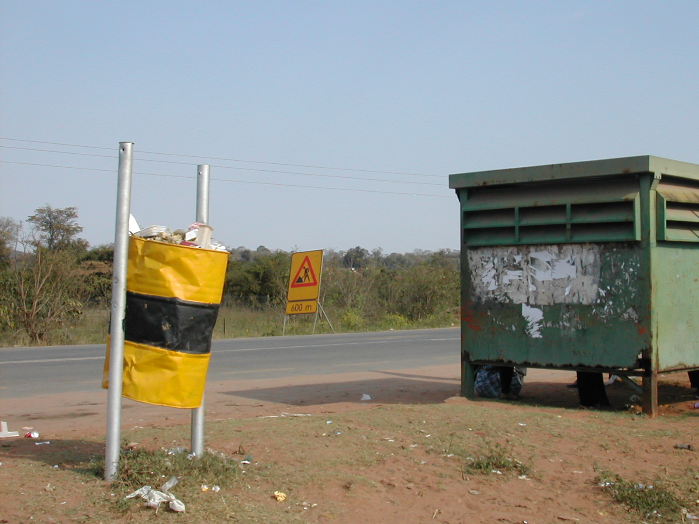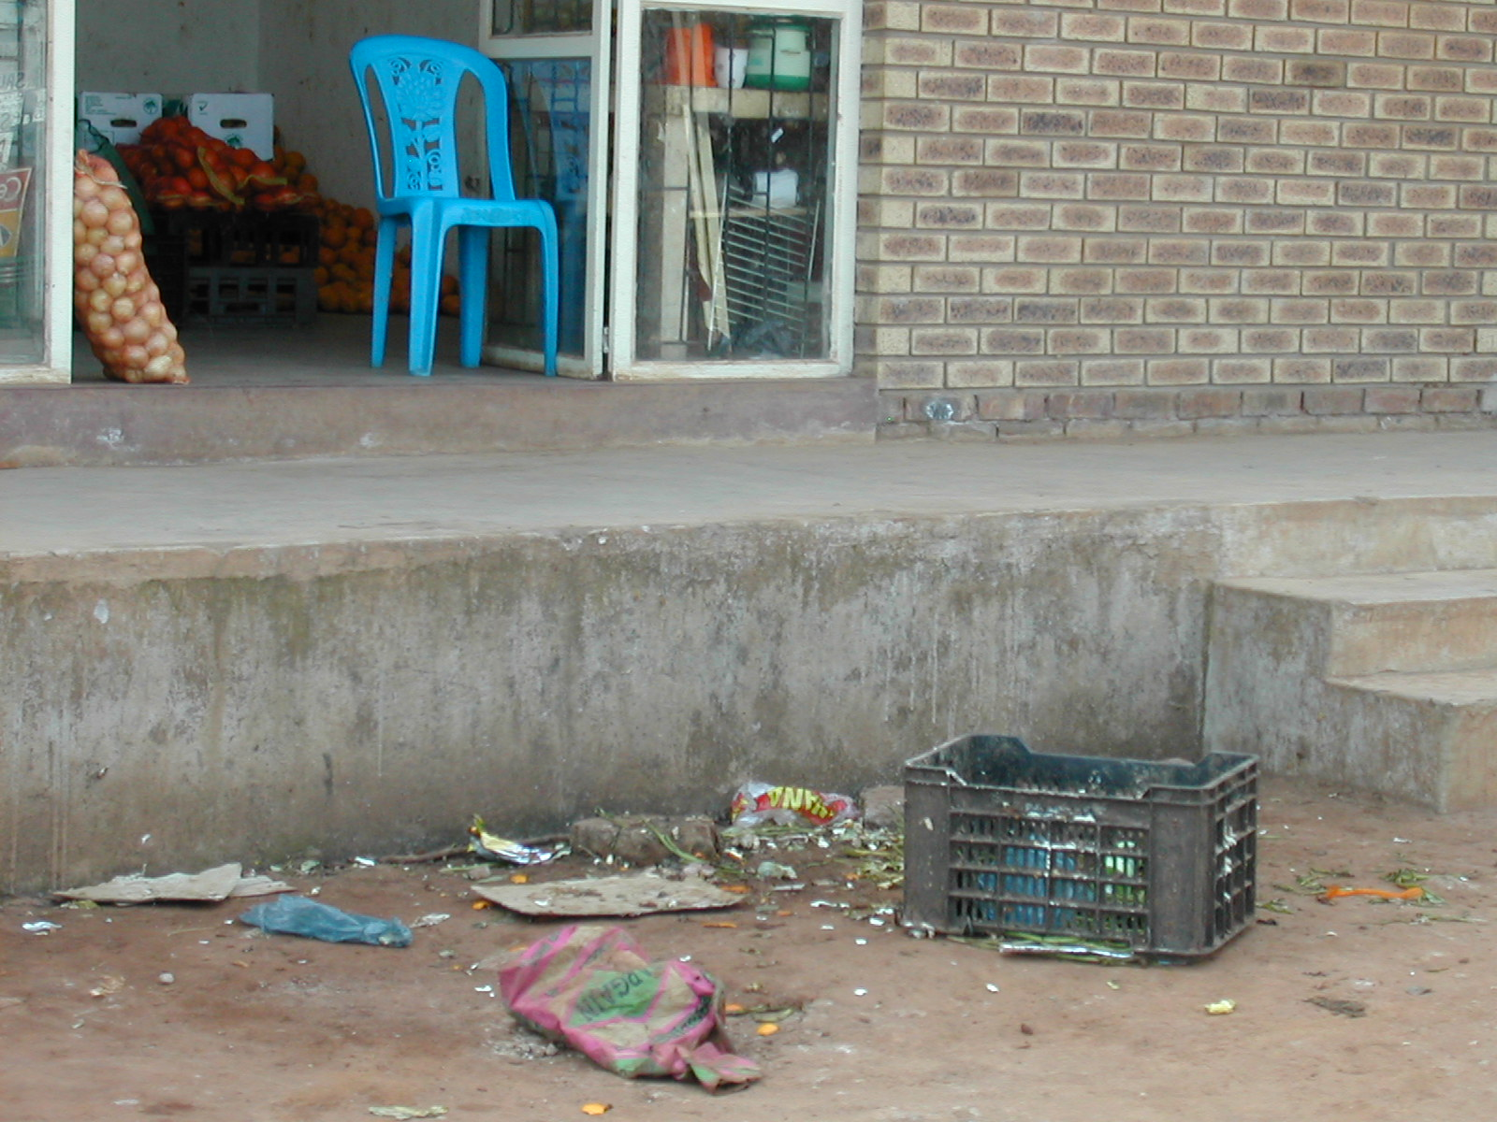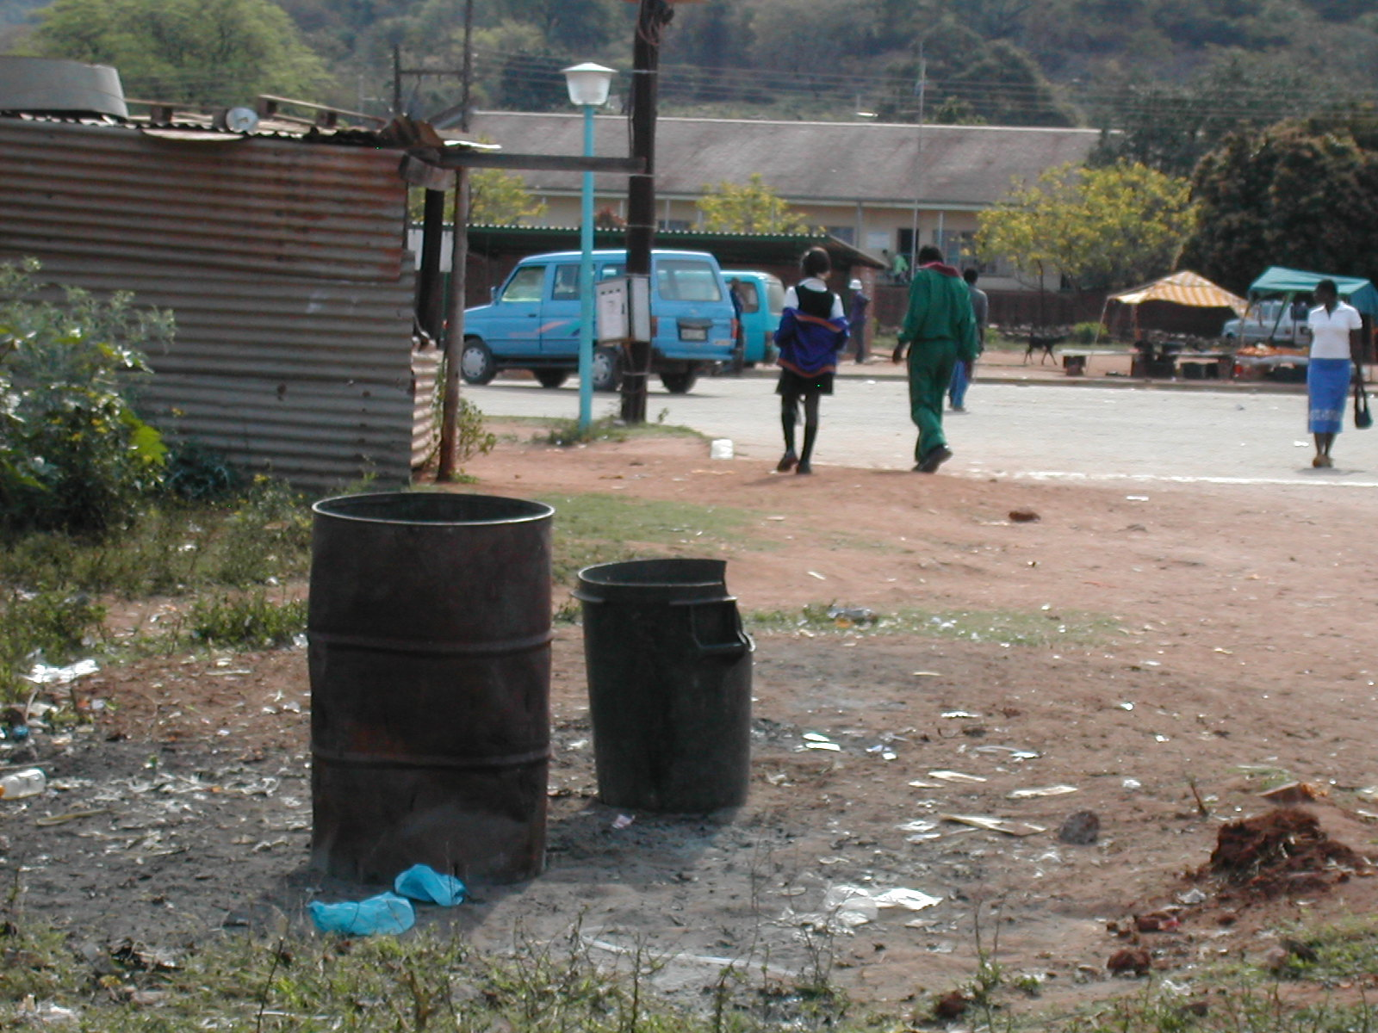
Figure 1: Refuse drums on entrance road Figure 2: Other bin types in Tshilamba Figure 3: Taxi rank in Tshilamba
The waste from public places is collected by the municipality and disposed at the Gundani dumping site which is located approximately 12km from the town. The municipality also collects waste from the healthcare centre, governmental institutions, two supermarkets, bottle store, petrol station and restaurant that make up the business areas of Tshilamba.
Figure 4 shows the enclosure where the waste from the municipality offices is dumped before being burned. The enclosure is filled with burned metal cans and residual ash.
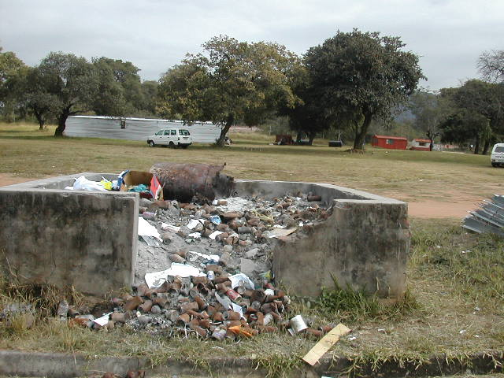
Figure 4: Pit for dumping and burning of municipal
Office waste

Masisi
Mutale collects waste in Masisi from households and businesses on Fridays. The current dumpsite used for the disposal of the collected waste is located far from the town. The dumpsite is not permitted and therefore operates as an illegal dumping facility that needs to be upgraded. People from Masisi buy their own plastic bags for waste collection. The municipality does not provide bins to the residents for waste storage.

Tshikondeni Mine
Waste collection at Tshikondeni mine is handled privately. Waste is collected daily and disposed at the dumpsite. The Tshikondeni mine truck is also used for collection of waste from various other places like residential areas, businesses, clinics and schools.
Table 1 shows the collection details for Mutale.

Table 1: Collection details of Mutale Municipality

Vehicles/Equipment
Mutale uses one flat truck for waste collection.

Recycling and reuse
Area | Collection Service | Equipment  Vehicles and volume | Frequency of collection |  | Rounds/vehicle /day | Time/ round | Dist. to disposal site (km) | Amount/day removed in (m³)
Area | Collection Service | Equipment  Vehicles and volume | Household | Business
Tshilamba | Municipality | 6t truck flat bedded loading space, 8m³ | Monday-Friday | Monday | 1-2 | N/a | App. 12 | 12
Masisi | Municipality | 6t truck flat bedded loading space, 8m³ | Friday | Friday | 1-2 | N/a | App.5 | 8
Tshikondeni mine | Private | 8t truck flat bedded loading space, 10m³ | Mon-Fri. | Mon-Fri. | 1-3 | N/a | App. 3 | N/a
There are no formally recognised recycling projects coordinated by the municipality. A small recycling business is carried out at the Tshikondeni mine dump site.

Composting
Composting is practised at Rambuda Farm, located at the western side of Tshilamba town. The farm covers an area of 240 hectares. A total number of 105 families are involved in farming at Rambuda farm. Each of these families has 1-4 hectares of farming area.
Some of the farmers use compost to improve the fertility level of the soil, whilst others make use of chemical fertilizers.
The farmers have two methods for compost use: -
- Organic waste is placed in a pit with manure and then cover with soil
- Organic manure is placed in a pit and covered with the soil. The pits are watered once per week and left for three months.
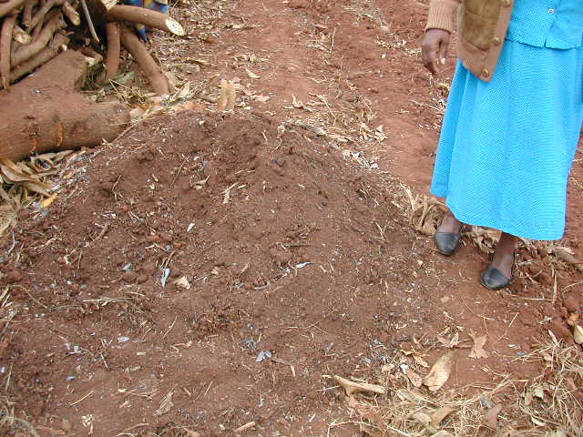
Figure 5: A manure compost pile on Rambuda farm

Treatment
Waste treatment modifies waste before final disposal.
The only identified treatment was the incineration of some medical waste.

Health Care waste
The municipality has one health care centre, 17 clinics, and three mobile clinics. All clinics and the health centre produce Health Care Risk Waste that requires special handling, treatment and disposal.

Mutale health centre
The health centre was established 20 years ago, with a total of 40 beds. It registers approximately 160-170 patients per month. There are approximately 25 daily inpatients and casualty admissions.
Dustbins with different coloured internal plastics are used for different types of waste. Red plastics are used for medical waste and black plastics for general waste. The sharps and syringes have special containers with capacities of 10L and 20L. When these are full they are taken for incineration. The health centre has an incinerator on the premises but it does not work due to mechanical failure, the sharp containers are taken for incineration to the Donald Frazer Hospital in Thulamela. The health centre has on its premises a large cemented placenta pit.

Tshipise clinic
Tshipise clinic is located on the north-eastern side of Tshilamba town. The clinic is fenced and has a staff of 19 people, 11 nurses, three cleaners and five security guards.
The clinic uses dustbins with different coloured internal plastics for different types of waste. General waste is collected in black plastics and medical waste is collected in red bags. Special containers are used for collecting sharps and syringes. The full containers are taken to Donald Frazer hospital for incineration.
The clinic has a cemented placenta pit. Another pit is used for the burning of general waste collected by the cleaners on a daily basis.
Figure 6 shows the placenta pit with a lockable gate. Figure 7 shows the general waste pit where waste is reduced by burning.
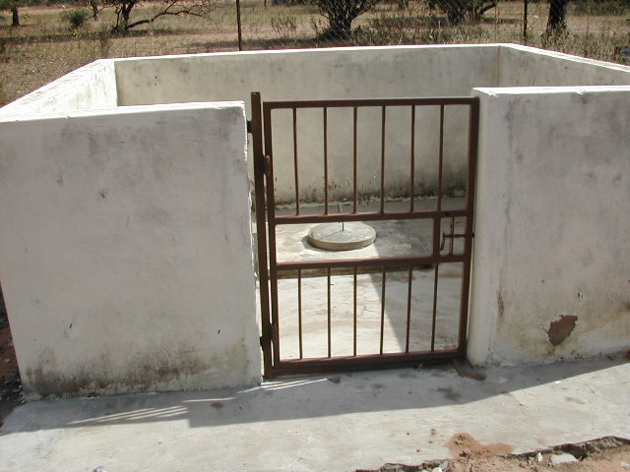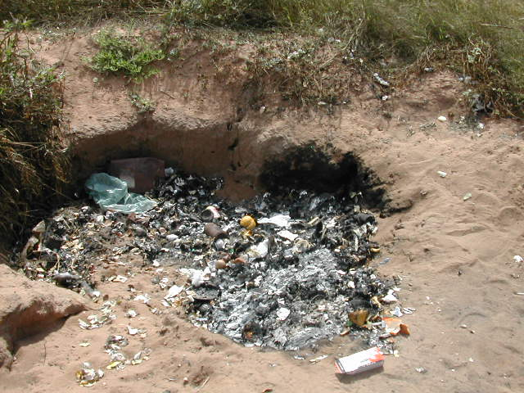
Figure 6 Placenta pit at Tshipise clinic Figure 7 General waste pit at Tshipise clinic

Private health services
Mutale municipality has two private clinics. One clinic is situated in Tshilamba town, adjacent to the main access road and the other clinic is located on the eastern side not far from the first clinic.
The clinics individually separate general and medical waste and each have a pit for disposal and burning of infectious waste. Sharps and syringes are collected in special containers to be taken for incineration. A contractor collects the full containers for incineration. The clinics pay R60 each for this collection service.
The municipality collects and disposes of general waste at the Gundani dumpsite once a week.

Final Disposal of waste
There are four recognised dumping sites in Mutale. Of these, three are municipal owned. These are Pile, Gundani and Masisi. The fourth is a privately owned site called the Tshikondeni Mine waste disposal site. None of the dumping sites in Mutale are permitted and are therefore operating illegally.

Gundani waste disposal site
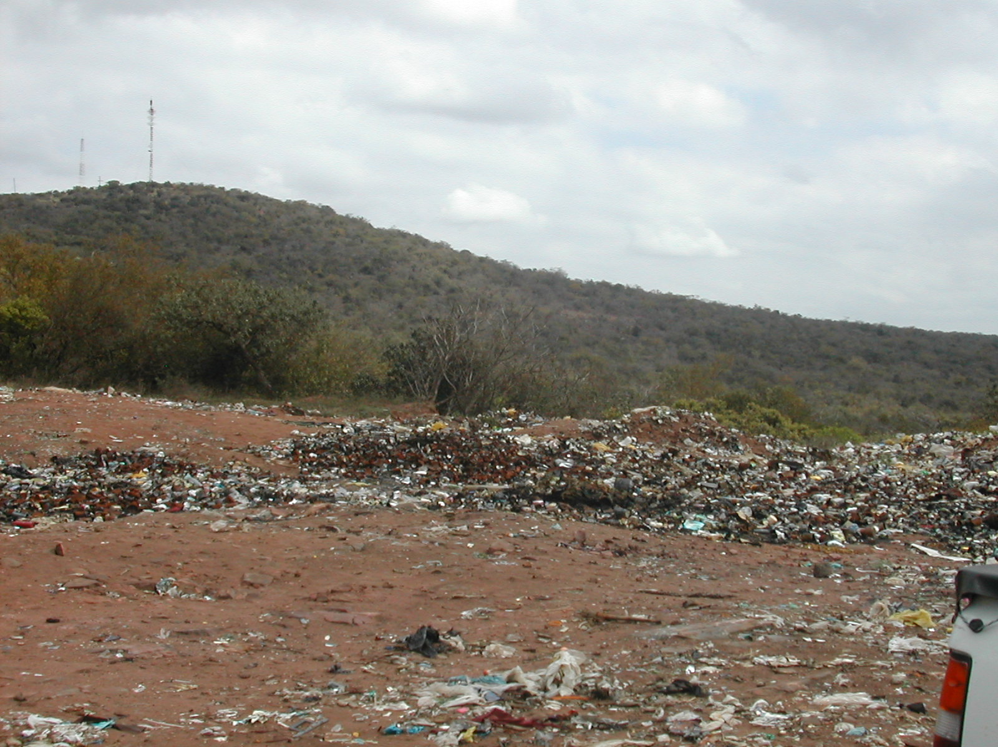
Figure 8: Gundani waste disposal site
The Gundani waste disposal site is located at the north-eastern side of Tshilamba town, approximately 12kms from the town and covers an area of approximately one hectare. The site is fenced but poor management has caused deterioration in the fencing and the lack of an entrance and exit gate poses entry problems, as the site is accessible to anyone. The site has no administration building, which poses a problem with regard to ablution facilities and a covered workstation for workers on duty. The dumpsite has been operating since 2000. The road from the main road to the dumpsite is in good condition. The road through frequent use may become dusty but the road in general is suitable for an access way for vehicles entering/exiting the site. If the site is identified for upgrading, then dust suppression by spraying may be a used.
The site itself contains burned metal cans and burned waste. Due to the high volumes of ash present on the site, reshaping of the site, in the event of upgrade, must be considered. The site is well located away from natural water resources human settlements. The nearest water resource is located more than 1km down stream of the site while the nearest settlement is approximately 2km away from the site entrance. Water supply to the site for site water needs may be drawn from water tanks located in the nearest settlement.
The municipality has employed a security guard but no training or protective clothing has been provided for the performance of his task.
The Gundani disposal site operates during normal working hours and serves the Tshilamba area and surrounding villages. All the waste collected in this disposal site is burnt, some of which is hazardous as it was evident that medical waste and syringes are also dumped at this site.

The site is fenced but not completely secure and waste covers approximately 30% of the total disposal capacity of the site. The presence of infectious waste and lack of protective gear for the guard on duty are problems that still require attention.
The dumping site has a buffer zone of approximately two kilometres away from the nearest settlement. There are no nearby rivers and the settlement community near the dumping site utilise tap water coming from a tank.
The municipality intends to upgrade the site to a permitted waste disposal site.

Masisi waste disposal site
Masisi disposal site is located at the southern side of the town of Masisi, approximately five kilometres away. The disposal site was reported to have been a gravel quarry before it became a waste dumping started. The site is not fenced, allowing people and animals free access onto the area.
Mutale has not acquired a permit from the DWAF to operate the site. A gravel road links the disposal site and main road; it is however not properly maintained since it is not regularly graded and watered for dust prevention.
There are no stipulated hours of operation and the municipality has yet to appoint staff at the site. Masisi disposal site serves Masisi town and surrounding communities. All waste collected at the dumpsite is burnt.
.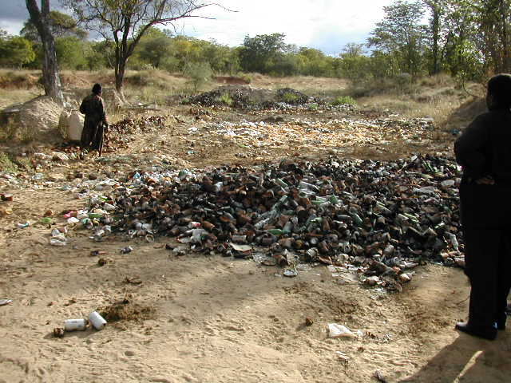
Figure 10: Masisi disposal site
The dumpsite has a buffer zone of approximately two kilometres to the nearest settlements.

Pile waste disposal site
The Pile disposal has a buffer zone to the nearest residential area, which is greater than the MR distance. The roads leading to the site have been flood damaged preventing current use, as the site is no longer accessible. A municipal decision was thereafter taken to close this site and open one in the Gundani area.

Tshikondeni (mine) waste disposal site
Tshikondeni waste disposal site is located in the mine yard. The area is fenced and is not a permitted waste disposal site. The road leading to the dumpsite is in an acceptable condition.
An employee of the mine serves as a security guard and is also responsible for sorting out recyclables such as metal, tins and glass.
An on site incinerator is used to burn boxes, paper, plastic and medical waste from the clinic. The ash is then dumped on an open site adjacent to the incinerator.
Figure 11: illustrates the type of incinerator in which paper, plastic and cardboard is burned. Figure 12 shows evidence of the ash from the incinerator dumped next to it. Ash coming from medical waste from the incinerator is considered to be hazardous and it must be handled with care.
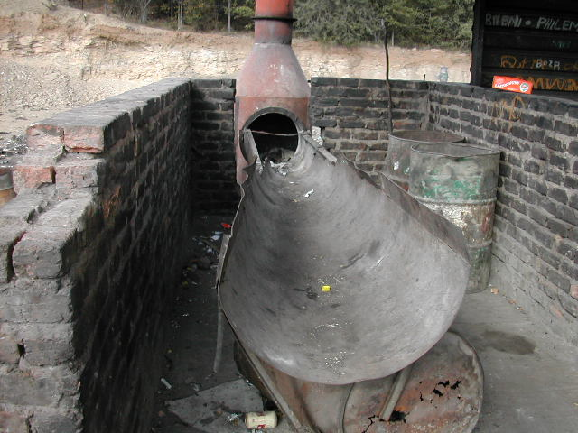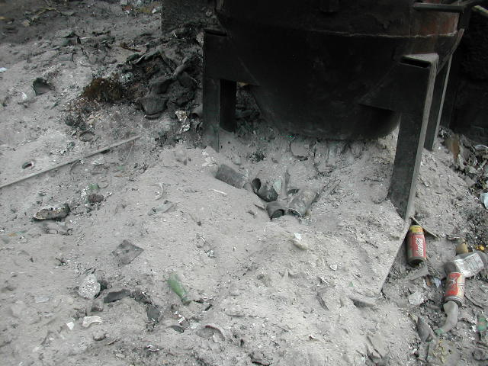
Figure 11: Incinerator at Tshikondeni disposal site | Figure 12: Incinerated ash dumped next to incinerator
An individual had been appointed to attend the recycling of tins and glass, but financial difficulties caused the halt of the project. An amount of sorted tins and crushed bottles still remain at the dumpsite.
Figure 13 and 14 indicate the sorted recyclables that remain on the site. Figure 13 shows bags filled with crushed bottles whilst Figure illustrates the heap of metal cans that lie in another section of the dumpsite.
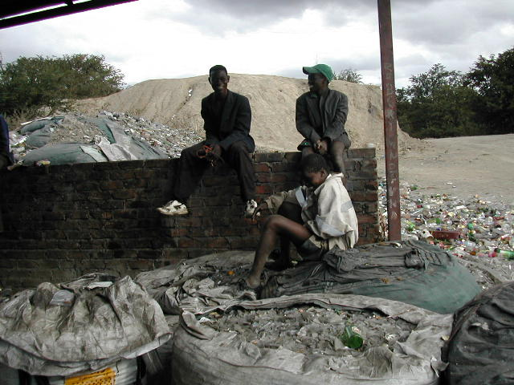 | 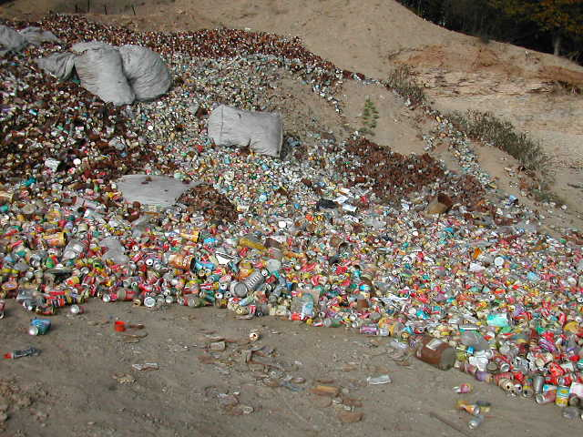
Figure 13: Bags of crushed bottles on site | Figure 14: Separated metal cans

Other disposal sites
In rural areas where the municipality does not render waste collection services, different methods of disposal are employed. Some people dispose waste in a pit where waste is burned. When the pit is filled with ash it is closed and another pit is excavated for disposal. Waste was also found dumped in open space and along roadsides.

THE INTEGRATED WASTE MANAGEMENT PLAN
In accordance with national policy this Plan is designed to accomplish a paradigm shift to Integrated Waste Management based on separation at source, composting of organics, and maximum recovery of non-organic recyclables and proper disposal of only the limited amount of remaining waste.
In order to accomplish these goals, the Plan sets forth the following short term strategy for immediate implementation.
The concept for waste management for the Mutale Municipality includes the integrated implementation of the following elements:
- Waste Management Policy
- Waste By-Laws
- Cleaner Production
- Separation at source
- Recycling
- Collection and transport system using appropriate equipment
- Permitted landfills
- Improved working conditions for salvagers
- Waste information system
- Organisational development
- Monitoring/planning
Development and adoption of a Waste Management Policy clarifies goals, promotes a paradigm shift towards Integrated Waste Management and provides an overview of the way forward. In addition, it provides an opportunity to include stakeholders in the process of planning and can ensure that the interests of all are debated and considered from the beginning of the implementation process.
By-laws establish a legal framework within which to promote and enforce the central elements of an Integrated Waste Management System such as separation at source and an end to burning of waste. While By-laws provide a legal framework they cannot directly and in isolation lead to desired change. For example, enforcing a ban on burning without offering an alternative could lead to an increase in illegal dumping.
Cleaner Production focuses on production processes in order to ensure that the volume of waste over the life cycle of a product is reduced and minimized. In addition, Cleaner Production focuses on the efficient use of natural resources including water and energy. For example, a more energy efficient production process can reduce the need to burn coal for electricity and reduce the generation of ash from power plants. In this way Cleaner Production is an integrated and preventative approach to environmental management that goes beyond the field of waste management itself.
Separation at source is the foundation for the Integrated Waste Management System. The goal of separation is to remove organic waste and non organic recyclables from the waste stream. In this way, the amount of waste that must be land filled is significantly reduced and waste management costs are reduced. Moreover, eliminating the landfill of organic waste dramatically reduce the generation of methane gas a dangerous green house gas. South Africa has committed itself to reduce production of methane as part of a global campaign to prevent global warming.
Recycling includes: Reuse, Composting and Resource Recovery. The objectives of recycling are to save resources as well as reduce the environmental impact of waste by reducing the amount of waste that must be transported and landfilled. Reusing an item longer or for different purposes reduces the need to purchase replacements. Composting removes organic waste from the waste stream and converts it into a useful product. This reduces collection, transport and landfilling costs, Moreover, it reduces the amount of biologically active material in the landfill and in this way reduces the generation of leachate and methane gasses in the landfill and this reduces management costs and risks to human health and the environment. Recovery of materials such as glass, cans, plastics and paper products can save production costs while it preserves natural resources.
The right equipment is needed to both improve the efficiency of existing collection services and to ensure that it is available to all residents.
For example, more expensive and sophisticated equipment such as Rear End Loaders (RELs) can provide efficient service in densely populated areas where the road/street conditions are good but the same vehicles cannot operate efficiently where settlements are less dense and road conditions are poor since such vehicles require high levels of maintenance.
At the other end of the equipment spectrum are non-motorised vehicles. Donkey carts are an example of such vehicles. Donkey carts have proven particularly effective in serving rural communities in several African countries like Botswana and Ghana where the use of motorised vehicles is impractical in some rural areas.
Donkey carts have many important advantages:
- Community ownership of waste management system
- Potential for small business development and job creation
- Encourage recycling and home composting
- Alternative to salvaging
- Low operating cost
- Low maintenance cost
- Potential to operate on a cost recovery basis
National policy and regulations require that the final disposal of waste occur only at properly constructed and managed landfills that are permitted and monitored by the Department of Water Affairs.
National policy will lead to the elimination of salvaging at landfills. But this will take some time and as an interim measure it is important to ensure that salvagers have proper working conditions. In addition, education and training should be provided to enable salvagers to make a transition to better jobs within waste management or in other industries.
National Government is establishing a waste information system to assist national government in coordinating implementation of a national Integrated Waste Management System. Mutale and Local Municipalities will be required to collect data and provide this to the provincial and national governments. In addition, the collection of this data will make it possible for Mutale Municipality to monitor and evaluate progress in implementing its own strategy.
Organisational development including:
- Developmental and strategically led local governance system
- Broad Based Black Economic Empowerment
- Municipal Service Partnerships
- Capacity building
is crucial to the success of all other waste specific initiatives.
The cornerstone legislation for municipal management adopted since 1994 provide the framework within which to establish developmental and strategically led local government. The Broad Based Black Economic Empowerment Act (2004) mandates government (among other things) to promote equity, skills development, affirmative procurement and enterprise development as it reorganizes, upgrades and expands its service delivery system. Municipal Service Partnerships can be used to promote cost effective and community based solutions for collection and recycling as well as other elements in the integrated waste management system. No progress can be expected without capacity building within the government and communities.
Monitoring and evaluation of initiatives is an essential element for long term planning. The ideal tool for capturing data and rendering it accessible for planning purposes is a Geographical Information System or GIS. Critical cost factors in waste management involve transport and collection. A GIS system can assist in route planning, site selection for collection points and waste disposal sites as well as the mapping of all essential data for planning purposes.
Implementing an Integrated Waste Management System requires promotion of individual responsibility combined with a municipal service delivery system. One without the other will fail. Thus, progress is dependant upon a commitment to encourage and support behaviour change by individuals and within municipal government.
The integration of individual responsibility and municipal delivery systems maximises the cost, human health, environment and job creation benefits generated by separation at source as part of an Integrated Waste Management System.

6. PILOT PROJECT FOR IMPLEMENTATION
Bazisa Technical Waste Solutions in collaboration with Mutale Municipality implemented (February 2005) a pilot project for rural integrated waste management in Gundani Village. The project has demonstrated that donkeys can be used for collection and separation at source makes it economically viable to implement recycling. The project is also designed to determine the actual costs involved in rural service delivery, promote research and capacity building for local municipality staff.
ANNEXURE B

MUTALE DISASTER MANAGEMENT PLAN

PREVENTION IS BETTER THAN CURE.

1. BACKGROUND

In terms of section 52 & 53 of Disaster Management Act of 2002 all Municipalities within the Republic of South Africa are requires to prepare Disaster Management plans for their Municipal areas.

In Mutale Municipal area there are many hazards that may cause disasters. These events can destroy and slow down years of development planning and implementation.

A plan is needed to prevent the occurrence of disaster or minimise its severity to protect the lives and properties of the communities. It is the responsibility of each institution to stay prepared to manage any disastrous event that may affect our area.

According to the Act the plan should:

1. Form an integral part of municipal IDP
2. Anticipate the types of disasters that are likely to occur in the municipal area and their possible effects
3. Establish the operational concepts and procedures associated with day to day operational response to emergencies
4. Identify the communities at risk
5. Provide for appropriate prevention and mitigation strategies
6. Identify and address weaknesses in capacity to deal with possible disasters
7. Facilitate maximum emergency preparedness
8. Contain contingency plans and emergency procedures in the event of disaster, providing for:

- The allocation of responsibilities to the various role players and co-ordination in the carrying out those responsibilities.
- The dissemination of information
- The establishment of strategic communication links
- Disaster recovery and rehabilitation focused on elimination or mitigation
- Prompt disaster response and relief

2 . OBJECTIVES

The following are the objectives of this plan:

- To develop and implement prevention and mitigation strategies.

- To determine the roles and responsibilities of various role players in order to ensure coordinated action in the event of disaster.

- To ensure that in time of disaster appropriate system procedures and resources are in place to assist those affected by disaster and to enable them to help themselves.

3 . IMPLEMENTATION 0F PLAN:

The responsibility for the implementation of the plan will be the Disaster Management Officer

4. TYPES OF HAZARDS IDENTIFIED WITHIN MUTALE MUNICIPAL AREA.

See annexure “A”

5. PREVENTION AND MITIGATION

The responsibility of the Municipality is not only to react to disaster but also to prevent the effects of disasters. It is the responsibility of each role player to implement the prevention and mitigation strategies as indicated in Annexure “A”.

6. ALLOCATION OF TASKS TO THE ROLE PLAYERS

Should there be any occurrence of disaster in this area each role player will be allocated with responsibilities.

See Annexure “B”

7. ESTABLISHMENT OF JOINT OPERATION CENTRE (JOC)

In time of disastrous events the Disaster Management Officer will activate the Role players to establish JOC.

The joint operation committee will perform the following functions:

- Issue public warnings
- Prepare list of fatalities, casualties and missing persons
- Co-ordinate response with non-governmental disaster relief organisation
- Prepare a list of destroyed and damaged properties
- Decide on emergency measures
- Establishment and maintenance of working groups to do effective disaster risk Planning
- Maintain records of communication, decisions and expenditures
- Provide information to the media for dissemination to the affected community and the general public

8. LIST OF LOCAL DISASTER MANAGEMENT ADVISORY FORUM MEMBERS.

See annexure “C”

9. COMMUNICATION
NATIONAL DISASTER RISK MANAGEMENT CENTRE

9.1 Line of communication

PROVINCIAL DISASTER RISK MANAGEMENT CENTRE

DISTRICT DISASTER RISK
MANAGEMENT CENTRE

LOCAL
DISASTER RISK
MANAGEMENT COMPONET

WARD DISASTER MANAGEMENT
FORUMS

9. 2 EMERGENCY NUMBERS TO REPORT DISASTERS AND RELATED
INCIDENTS

1. DISASTER MANAGEMENT UNIT : 015 967 9000
082 398 9736

2. MUTALE FIRE STATION : 015 967 0121/3

3. MUTALE SAPS : 015 967 0681

4. MAKUYA SAPS : 015 957 9200

5. MASISI SAPS : 015 966 5568/9

6. TSHAMUTUMBU : 015 539 0629

7. MUTALE FIRE STATION : 015 967 0123

9.3. PUBLIC WARNINGS

Public warnings will be sent through ward councilors

10. RESOURCES

The following institutions will assist with resources during disastrous event:

RESOURCES | INSTITUTION
1. Road machineries | - Municipality  - Roads and Transports
2. Accommodations | - Municipality  - Education  - Churches  - Traditional leaders  - PDMC
3. Transport | - Municipality  - Roads and Transports  - Tribal Authorities  - DWAF  5. Social Development  - Environmental Health
4. Communication facilities | 1. Municipality  2. SAPS  3. PDMC

10.1. RESOURCE MANAGEMENT

In time of disastrous event the list of all resources will be kept by the JOC

The JOC will also be responsible for the allocation of resources but the maintenance of equipments and overtime payments will be done by the relevant institution.

11. INSTITUTIONAL PLANS

Each role player in Disaster Management within Mutale municipal area is expected to prepare its own disaster management plan and submit a copy to the Municipal Disaster Management Officer.

The plans for sector departments should be focused on the following:

- Risk and vulnerability Assessment leading to needs analysis
- Its capacity to fulfill its role and responsibilities
- Prevention through risk elimination
- Prevention though risk reduction
- Preparedness planning for risk that can non be eliminated
- Lines of communication
- Awareness and Education

12. RESPONSE TEAMS

Should there be an occurrence of disaster in our area the response teams will be established and activated to perform the following functions:

- Assessment of damages
- Supply disaster relief to the victims
- Evacuate the victims to the safe places
- Compile assessment reports
- Compile and keep records for all items received by the Municipality
- Compile and keep records for all items delivered to the victims
- Control storeroom for disaster items
- To liaise with the Disaster Management co-ordinator

13. INTEGRATION OF DISASTER MANAGEMENT PROGRAMS IN THE IDP

In order for Disaster Management section to perform its functions effectively the following program should be integrated in the IDP:

- Hazards and Risks assessment
- Launching of Disaster Management forums
- Trainings for WDMCs, LDMAF and Municipal staff
- Disaster Management Mock Drill
- Community awareness.

COMPILED BY DISASTER MANAGEMENT SECTION: MUTALE LOCAL MUNICIPALITY

ANNEXURE C.

MUTALE MUNICIPALITY COMMUNICATION STRATEGY

- Introduction

Communication strategy of Mutale Municipality takes cognizance of the fact that communicators communicate in a complex environment, competing for attention with voices that have objectives that are different and often opposing, and in a world in which everyday concerns weight heavily on most people

- Mutale Municipality fully comprehend the fact that communication is very much more that just media liason’therefore the municipality will adopt and implement a comprehensive multi-facet communication strategy

Mutale Municipality like all other public sector bodies serve many masters who demand openness and accountability, the municipality also has the right and obligation keep certain information confident.

Communication service of this Municipality also recognize the important role that internal communication plays in any institutution/organization .Living the brand internally is critical toMutale Municipality specific strategies and deliverables.

As the municipality communication services, and as communicators, our biggest challenge is the need to address perceptions, culture and thinking. We should always be on the guard against communicating, disintegrated, uncoordinated conflicting and fragment message, as it often said in communication circles that a thousand voices speaking without a common message and a single purpose will in the end just make an distinct noise that few will hear.

2. Background

Mutale Local Municipality is one of the four municipalities comprising the four District Municipality. .It is situated in the far north eastern corner of the District. It serves a population of 95 712(Municipal IDP)SPREAD OVER 150 Villages. The total land cover of the Municipality is 2375,78212 Hectares. The Kruger National Park forms the eastern boundary of Mutale Local Municipality, with the great Limpopo River forming the North-eastern boundary. The Municipality’s strategic location affords. It may opportunities for tourism economic development.

Mutale Local Municipality shares borders with Musina Local Municipality to the North, Makhado Local Municipality to the South. The Municipality is accessed through R525 linking the Kruger National Park to other Local Municipalities within Vhembe District. It can also be accessed through R linking Thohoyandou and Mutale.

Mutale Municipality is located North –east of Vhembe district .The municipality has 11 wards, 22 councilors and 7 Mahosi in the council. Its population of 120-000 people predominantly speaks Venda.

Mutale Municipality economy is based on mining, Agriculture and Tourism industries.

“Three spheres of government speaking in one voice sending a consistence message”
The key factor of a social marketing and communications programme is that the customer is regarded as the bottom line for judging its success. This is similar to the behaviorists approach but unlike the educators approach. Marketers communicators may be satisfied that messages were distributed and received and that people have apparently learned some facts .Social marketers argue that learning facts is only important if it leads to a desired behavioral outcome.

This strategy document is premised on the end to take seriously and embrace the notion of (developmental communication) . There are seven core elements to developmental communication.
- Is empowering and responds to the needs of the communities stakeholders .It has as its pivotal message the improvement of the quality of the citizens
- Is interactive and is informed by continuous feedback.
- Is innovative and creative .It makes use of a combination of current technology and the line communication which is appropriate to the context in which communication takes place.
- Enhances participatory democracy .This approach builds participatory mechanisms into the strategy ,i.e. all audiences or municipal stakeholders are encouraged to interact and inform municipal communication channels.
- Is sustainable. Communication channels most are continuous and regular. Communities must come to expect and rely on particular channels of communication. This ensures that they are kept current with municipal activities, and have an opportunity to provide feedback to the municipality.
- Is accessible. This means that channels of communication are available to all stakeholders and not merely the most influential or the most easy to access. Accessibility must apply to language especially Tshivenda
- Is educational. Information provided must contribute to an improved community who are better able to access and benefit from municipal services.

This communication strategy is based on the following:

- The National GCIS Framework.
- Municipal System Act (Act 32 of 2000)
- The Constitution of the republic of South Africa (Act no 108 of 1996)
- Provincial Communication Conference co-organized by SALGA and Lampoon Government ( 2002)
- District Communication workshop ( 2003 and 5 )
- Premier’s opening of the Legislature.
- The state of the Nation address by the President -SONA
- The state of the Province Address-SOPA
- State of the District Address-SODA
- Mutale Municipality IDP

- VISION

To provide communications services in accordance with Mutale Local municipality IDP, to enable effective, efficient, two-way communication between the municipality and its immediate stakeholders with particular emphasis on developmental municipality that ensures sustainable, economic growth and equitable service delivery .

3. Objectives

- To enhance effective communication between Mutale municipality, communities and sector departments.
- To enhance and co-ordinate activities of National, Provincial and prostates at the local sphere of Government.
- To project the positive image of the municipality locally, provincially, nationally and internationally.
- To inform and educate the public about the work of government.
- To forge links with the Media.
- To develop and maintain correct public perceptions on Government delivery.
- To ensure that we communicate our common messages on priorities said by government.

CORE VALUES
  - Access
  - Transparency
  - Responsiveness
  - Service
  - Knowledge and learning
  - Professionalism .

4. Environmental Analysis

- Hostile media, unmediated communication. Creating a friendly environment with the media and a platform of communication between Mutale municipality, communities and sector departments.

4.1 Political

- Mutable municipality is politically characterized by the presence of the Democratic Alliance, Azanian People’s Organization, and African National Congress.
- African national Congress is the leading party in Mutale Municipality

4.2 Economical

- Mutale Municipality is mostly rural with high poverty and illiteracy rate.
- The municipality has been identified as having potential in the mining, agriculture and tourism.
- It is the fastest economic growing municipality in the district

4.3 Public Mood

- People at grassroots level complain about service delivery
- People perception is that Government is slow in terms of delivery.

4.4. Media Agenda

- Positive coverage is enjoyed at some public broadcasters and local at certain issues, though there is a lot of negative coverage on government and its programmers by the commercial media.
- The community radio station is operating but does not cover all the areas in the Municipality.
- Local media available comprise of Phalaphala F.M,Univern F.M,Mirror
- National television stations hardly respond to invitation unless on negative issues.

4.5 Demographics and Psychographics

- Mutale Municipality is predominately rural with maximum support of Traditional Leaders.
- Poverty, illiteracy and lack of employment’s form part of the daily problems.
- Language spoken in Mutale Municipality includes Tshivenda,Tsonga ,English & Afrikaans
.

4.6 Institutional arrangements

- Mutale Municipality Communication Forum should be a component of the Vhembe District Government communicator’s Forum.
- Mutale Municipality Communication Forum be chaired by Mutale Municipality Communication Official
- Mutale Municipality should have full functional Communication directorates.
- Mutale Municipality Communication Manager be part of Vhembe District Communicator’s Forum and its management Committee.
- Communication structures be aligned in all spheres of Government as follows:
- National Government Communicator’s Forum - Provincial Government Communicator’s Forum - District Government Communicator’s Forum and Mutale Municipality Government Communicator’s Forum.

4.7 Legal Provisions

- Chapter 7 of the Constitution of the Republic of South Africa (Act number 108 of 1996.)
- The Management Structures Act 117 of 1998.
- The Municipal System Act. ( Act 43 of 2000)
- The Municipal Demarcation Act of 1998.
- The Municipal Finance Management Act ( Act 56 of 2003)
- The Preferential Procurement Policy Framework Act.

5. STRUCTURE AND PROCESS

The communication unit exists to provide support to the political and administrative arms of Vhembe district municipality and council.

The head of the unit will report political to the major and administratively account to the municipal manager

- Key function of this unit is to strategically lead communication in the municipality so that the people of vhembe participate actively in their development and governance

- The unit should be organized in a way that it provide this support in a manner that:

  - Support and enhance the vision and strategy of the district municipality

  - Support and enhance the government’s development priorities and agenda, national provincial and local

  - Support and enhance the national government communications strategy and agenda

MANAGING CRISES

- While it is unarguable that crisis management should not be the de facto manner of operation, from time to time crisis will arise. To this end, the following approach should be employed.
- Pre—empts crises by ongoing communication with the media, as well as buy strictly adhering to the media strategy. A Media strategy should be designed and implemented for each of the municipality process
- Identify the crisis and assess the nature and scale of the potential and actual damage
- Co- ordinate an ad hoc crisis management committee. The committee should be consisted of people in leader position, technical expert’s relevant people from other departments and a support team.
- All communication should be centralized through this committee. The committee should only have one spokesperson
- Senior management must be involved in management of the crisis. Their involvement should be visible. This ensures uniformity and credibility of message

DEALING WITH NEGATIVE PUBLICITY

All interaction with the media must be strategic .This means that the timing ,the channel(i.e. Phalaphala f.m Univern f.m Mirror. Sowetan The particular Journalist involved

- Before responding to negative media the following should be considered
- Is the negative coverage widespread, or confined to a particular area?
- Does the coverage have short- medium –and long –term implication?
- What is the exact nature of the message?

STRUCTURE AND PROCESS

- The communication unit exists to provide support to the political and administrative arm of Mutale Municipality and the council. The head of the unit will report politically to the Mayor and administratively account to the Municipal Manager.
- The key functions of this unit to lead communications in the Municipality so that the people of Mutale actively participate in the development and governance.

STUCTURES

Mayor
Head
Of
Communication
Media Liaison Officer
Mayor’s Spokesperson
Media Relation
Communicant Research
Communication & Marketing
Outreach, Imbizo Community Liaison
Administrator

6. HEAD OF COMMUNICATION

- The head of communication is the overall Manager of communication components.
- Is the spokesperson of the municipality?
- Sits in the management and to the executive respectively.
- Oversees the implementation of the communication strategy.
- Promote and manage the integration of communication with all spheres of government.
- Chairs all communications co—coordinating forums within the municipality.
- Compile communication strategy and be responsible for the implementation
- Continuous profiling “good news “stories within the municipality.
- Give assistance on protocol related issues
- Plan and ensures participation in imbizo focus week.
- Compile messages for current affairs and issues for discussion at the council meetings.

7. COMMUNICATION SUPPORT TO THE MAYOR

- The communication manager or the spokesperson of the mayor should support the mayor in all media –related activities and function, these include the following;
- Organize, manage and facilitate media conferences in line with the media strategy
- Communicate the commitment made by the mayor
- Write articles, speeches. And media statement
- Organize interviews and information sessions.

8. COMMUNICATION CYCLE

- Communication cycle of the municipality should be the mirror of the IDP
- It is undisputed fact that the state of the Nation Address (SONA), the state of the Province address (SOPA), and the Minister of Finances Budget speech are features that inform our communication strategies. It is true that the municipal financial term begin in July.
- It would therefore be ideal that the communication cycle of the municipality begin in February after the SONA.,SOPA and the National budget speech and ends in February of the following year

9. NATIONAL, PROVINCIAL AND LOCAL GOVERNMENT CYCLE.

- Lack of reporting on decision made by the council.
- Popularizing of the programmed of Action on the implementation of IDP and the ISRDP programmed.
- Strengthening relations with media stakeholders.
- Intensifying communication on LED/economic opportunities.
- Strengthening confidence of municipal programmers.
- Building partnership with other stakeholders.
- Create a better way for people to complain about lack of service.
- Communicators not sitting in the management and decision making bodies.
- Inclusion of municipality in the interdepartmental forums.
- Making sure that government institution within Mutable Municipality sent common messages without getting into a competition.
- Developing and maintaining positive public perception on government programmers and activities.
- Provide feedback on government programmers at the local level.
- Develop and maintain positive relations with the media.

10. CORE MESSAGES

10.1 Mutale Municipality Core message

Improving quality of service delivery.

10.2 Sub - theme

- Wider access to services.
- Information is power

11. KEY PRINCIPLES.

11.1 People centered approach

- All programmers of government should be people centered.

11.2 Strategic Communication

- The strategy should place the political principal correctly on the strategy i.e. on top.
- Mutable Municipality Mayor and council programmers should be co-ordinate in a way that they do not divide the audience.
- “One Government, one voice and a consistent message.

11.3 Communication management and services

- The principle of Batho Pele should inform the communication strategy.
- Mutale Municipality is obliged to take information to the people.

11.4 Development Communication

- Our communication strategy should take into account the needs of society, the developmental goals of government and the general empowerment of our people.

12. MESSENGERS

- Principal messenger: Mutale Municipality Mayor.
- Support messenger: Mutale Municipality Municipal Managers and Councils and Councilors.
- Communicators.
- Traditional Leaders.
- CDW’ s
- Community structures
- Churches
- NGO’s

13. AUDIENCE

- Media.
- Communities in Mutale Municipality.
- Public Servants.
- Business sector
- Organs of civil society.
- Schools.

14. COMMUNICATION CHANNELS

14.1 Outreach programmed

- Council meets the people.
- Imbizo).
- Departmental outreach programmers,
- MPCC Road shows.
- Information Days.
- State of the nation address.
- CBOs.
- NGOs.
- Educational institutions.
- Business service centers.
- Religious institutions.
- Dzikhoro ( traditional Courts and gatherings)
- Community radios.
- MPCCs,
- Promotional materials.
- Salga

14.2 The use of Mass Media

- A communication plan should be done for every campaign / event to identify relevant media as per the type of audience targeted.
- Mutale Municipality and the Community media should enter into discussions to find ways of assisting each other in ensuring that Government programmers are communicated event to the poorest of the poor.

14.3 Internal Communication

- There should be notice boards strategically placed that are frequently updated for internal stakeholders.

14.4 Production of Information Material

- Mutable Municipality should produce quarterly newsletter external and Monthly for internal stakeholders.
- Departments operating within Mutable Municipality should produce other information materials as well as promotional as per demand.

15. EXPLANATIONS ON THE COMMUNICATION CYCLE.

March / April
- IDP/Budget Consultative meeting.
- Align of IDP campaign with Imbizo focus week as marketing tool.

May
- Communication strategy and IDP Budget consideration and adoption.
- Submission of plans with costs.

June / July
- State of District Address.

July
- Implementation of the strategy.

Dec / March
- Review of the strategy.

April
Development of New strategies

16. COMMUNICATION PRINCIPLES

Marketing and communication needs to be seen as an integral tool in the operations of the Mutale local municipality. To this end , communicators should adopt the following marketing and commutation principles ;
- Communication must be seen as an ongoing and continuous activities
- All issues and activities which arise within the municipality must be viewed and considered in terms of their communication implications
- All communication issues must be viewed from an internal and external perspective
- Whenever possible communication must be proactive and not reactive
- Crisis communication should be seen as the exception to the communication principles rather than the modus operandi of communication.

17. COMMUNICATION CAMPAINGNS SHOULD HAVE;

- A brief which is clear, specific and has a set of measurable objective
- A Well- articulated municipal positioning statement i.e. How do you want your audience to perceive your campaign
- A Carefully considered campaign LOOK AND FEEL
- Detailed audiences profiling
- Appropriate audiences messages
- Alignment of budget to campaign needs , and the overall communication budget

18. OPERATIONAL PLAN

19. OUTREACH PROGRAMMERS.
- Council meets the people, Imbizo, IDP consultative meetings, Departmental outreach programmers, MPCC Road shows, Information Days, State of the nation address, State of the Province address, State of the District Address, State Municipality Address, Celebration and National and commemorative Days should be carried out.
- Focus should be on economic opportunities.
- Mutale Municipality Mayor, Sector Departments and Municipal Managers should be part of the all these community programmers.
- More exhibitions should be done at these programmers.
- Achievements should be communicated trough these programmers.
- These outreach programmers should be evaluated and improved with time.
- Communicators should participate more in the planning and execution of outreach programmers.

20. THE USE OF MASS MEDIA
- Informed by the demographics, psychographics and behaviorist characteristics of the Mutale Municipality imperative that the mass media be used to maximally capture all members of our community.
- Priority should be placed on the most commonly used tools of mass media information.
- Local, Regional and community media with an emphasis on radio should be taken into account.
- Communicators should communicate to the public through the advertorials, letters to the editor, talk shows, face to face and opinion articles.

21. EXTERNAL COMMUNICATIONS.
- External newsletters.
- Exhibitions.
- Workshop and conferences.
- Community meetings.

22. INTERNAL COMMUNICATIONS

- Mutable Municipality newsletter is produced monthly.
- Departments should develop brochures, flyers and leaflets and other information material.
- Mutale Municipality and departments should conduct exhibitions in places such as the shopping centers, Arts, Craft and Sport centers, MPCCs, Parks , Community Halls, Local Business centers, etc.

23. COMMUNICATIONS FORUM.

The communication forum emphasizes the following principles:
- Consistency
- Regular reports
- Regular attendance

24. COMMNICATION PLAN SCHEDULE
- Focus on the economic opportunities
- Plan embrace vertical and horizontal communication component

25. IMPLEMENTATION STRATEGY

Mutale Municipality communication budget covers the following vertical and horizontal calendar of events

MONTH | ACTIVITY | TIME FRAME
July | Mutale Municipality Municipal Budget | July 2007
July | Mutale Municipality IDP Campaign | July 2007
August | Mutale Municipality National Women’s Day | 9th August2007
September | Mutale Municipality Arbor week | 1-7 September 2007
September | Mutale Municipality International literacy Day | 8 September 2007
September | Mutale Municipality Heritage Day | 24 September 2007
September | Mutale Municipality GCF’s Workshops | 30 September2007
September | Mutale Municipality MPCC LISSC Roads shows and Workshops at | 30 September2007

October | Mutale Municipality Imbizo focus week | 31 October 2007
October | Mutale Municipality Mayor’s messages of support to learners writing examinations | 1st October 2007
November | Mutale Municipality 16 days of activism | 25 November 2007
December | Mutale Municipality World Aids Day | 01 December 2007
December | Mutale Municipality International Day for Disabled Persons | 03 December2007
December | Mutale Municipality Mayors Christmas messages | 15 December 2007
December | Mutale Municipality Mayors New Year messages | 26 December 2007
January | Mutale Municipality Back to School Campaign | 15 January 2007

February | Mutale Municipality SONA  Mutale Municipality SOPA  Mutale Municipality Provincial Treasury Budget Speech | 28 February 2007
February | Mutale Municipality STI/Condom Week | 9-14 February 2007
March | Mutale Municipality South African Library week | 14 – 18 March 2007
March | Mutale Municipality World Consumer rights day | 15 March 2007
March | Mutale Municipality Human Rights Day | 21 March 2007
March | Mutale Municipality Sports events | 31 March 2007
March | Mutale Municipality Awareness Days | 31 March 2007
March | Mutale Municipality World Tuberculoses Day | 24 March 2007
March | Mutale Municipality National Water week | 21-27 March 2007
April | Mutale Municipality Imbizo focus week | 9 April 2007
April | Mutale Municipality Freedom Day Celebration | 27 April 2006
May | Mutale Municipality Workers Day | 1 May 2007
June | Mutale Municipality Youth Day | 16 June 2007
June | Mutale Municipality World Environmental Week | June 2007
June | Mutale Municipality International Day against Drug abuse | 26 June 2007

ANNEXURE D

SPATIAL DEVELOPMENT FRAMEWORK

CHAPTER 1

INTRODUCTION
  - APPOINTMENT
Mutale Local Municipality has appointed a service provider to compile a Spatial Development Framework (SDF) for them. The service provider is Hannes Lerm & Associates (Town Planners) in a joint venture comprising of Glen Steyn & Associates (Development Economists) and Management & Development Strategies (Development Planners). Following below are the deliverables as expected by the local for the MSDF. These deliverables form part of the Terms of Reference as contained in the relevant advertisement as received by the service provider. It is expected by the Municipality that the appointed service provider delivers on these outputs, and that they should be accepted as part of the contract.

  - PROBLEM STATEMENT

Previously development policies such as segregation, lack of access to opportunities for the urban poor and urban sprawl are still evident across the local despite the progress made by the Government since 1994 in formulating and promulgation of relevant ameliorating spatial planning legislations and policies. To date, fragmentation continues unabated.

Main clues include a displaced urbanization and settlement pattern that is distorted, fragmented, unequal, incoherent and inefficient. Most of the poor are located far way from places of economic, cultural, recreational and educational opportunities. The District is faced with the following challenges in the field of spatial development:

- The integrated Development Plan (IDP) of a local municipality is prepared in terms of the municipal system act, no 32 of 2000. One of the requirements of the said act is that IDP should contain a spatial development framework (SDF).

- The SDF needs to be informed by the vision of the municipal area, the development objectives and outcomes envisaged for the next 5-years as well as the strategies and outputs identified in the IDP. The SDF is therefore the spatial presentation of the restructuring and transformation objectives of local government also ensuring that a more sustainable land use pattern and optimum utilization of space are established. Dysfunctional spatial pattern and land use management systems.

- Uneven social development
- Infrastructure disparities and deterioration
- Skewed and scattered settlement patterns
- Demographic imbalances
- Environmental deterioration

  - OBJECTIVES OF THE PROJECT

The main objective of the project is to restructure the current spatial pattern, ensure equity, efficiency, sustainability, integration and economic growth in order to contribute towards eradication of poverty. Such plan shall ensure a well spatially coordinated district and facilitate alignment of municipalities’ spatial plans both vertically and horizontally.

  - RELATIONSHIP BETWEEN THE SDF AND THE LUMS

The SDF should be flexible and able to change to reflect changing priorities, whereas the land use management scheme should be tighter and only amended where required for a particular development. The SDF should therefore inform the content of the LUMS, rather than to act as a direct source of rights and controls itself. In this regard, the SDF should:

- Only be strategic, indicative and flexible forward planning tool to guide planning and decisions on land development.
- Develop an argument or approach to the development of the area of jurisdiction, which is clear enough to allow decision-makers to deal with the unexpected.
- Develop a spatial logic which guides private sector investment
- Ensure the social, economic and environmental sustainability of the area.
- Establish priorities for public sector investment.
- Identify spatial priorities and places where public-private partnerships are a possibility

The rural context will be necessary also to deal specifically with natural resource management issues, land rights and tenure arrangements, land capability, subdivision and consolidation of farms and the protection of prime agricultural land.

The purpose of the SDF is not to infringe upon land existing rights but to guide future land uses. The maps should be used as schematic representation of the desired spatial form to be achieved by the municipality in the long-term. The boundaries created through this process should therefore be left for interpretation and not be scaled
The SDF needs to be informed by the vision of the municipal area, the development objectives and outcomes envisaged for the next 5 years as well as the strategies and outputs identified in the IDP. The SDF is therefore the spatial presentation of the restructuring and transformation objectives of local government also ensuring that a more sustainable land use pattern and optimum utilization of space are established.

  - CONTENTS OF AN SDF

According to the white paper on spatial planning and land use management, The SDF should comprise the following four components:

- Policy for land use management
- Guidelines for land use management
- Capital expenditure framework for spending
- Strategic environmental assessment

The SDF must take the following into consideration:

- Give effect to the development facilitation act (DFA) principles
- Set out objectives that reflect desired spatial form
- Set out basic guidelines for land use management system
- Set out capital investment framework for development programmes
- Incorporate a strategic environmental assessment of the SDF
- Identify programmes and projects for development of land as identified on the IDP
- Be aligned with the neighbouring SDF’s
- Provide a visual representation of the desired spatial form of the municipality, which is namely:
      - Must indicate public and private land development and infrastructure investment
      - Must indicate desired/undesired utilization of space
      - Must identify areas where strategic intervention is required
      - Must indicate where priority spending is required

  - FORMAT OF THIS REPORT

The SDF document for Mutale municipality will consist out of the following:

CHAPTER 1: INTRODUCTION
CHAPTER 2: SPATIAL INTERPRETATION OF IDP
CHAPTER3: SPATIAL ANALYSIS
CHAPTER4: SPATIAL GOAL
CHAPTER5: IMPLIMENTATION STRATEGIES AND PROGRAMME
CHAPTER6: CONCLUSION
CHAPTER7: ANNEXURE

CHAPTER 2

SPATIAL INTERPRETATION OF THE IDP OF THE MUNICIPALITY

  - MISSION & Vision

“A DEVELOPMENTAL MUNICIPALITY THAT ENSURES SUSTAINABLE ECONOMIC GROWTH
AND EQUITABLE SERVICE DELIVERY”

2.2 WHITE PAPER ON SPATIAL PLANNING AND LANDUSE MANAGEMENT

The White Paper on Spatial Planning and Land Use Management (WPSPLUM) contains principles and norms, collectively forming a vision for land use and planning in the country. The overall aim of the principles and norms relating to spatial development is to achieve planning outcomes that:

- Restructure spatially inefficient settlements,

- Promote the sustainable use of land resources in the country,

- Channel resources to areas of greatest need and development potential, thereby redressing the inequitable historical treatment of marginalised areas,

- Take into account the fiscal, institutional and administrative capacities of role players, the needs of communities and environment,

- Stimulate economic development opportunities in rural and urban areas, and

- Support an equitable protection of rights to and in land.

These national policies create a concrete mechanism in which integrated development can be achieved by all the sphere of government. They also provide what policy articulation could mean in practice since they promote the compilation of IDP’s. The Mutale ISDF should represent a desired pattern of development as stipulated in these national policies.

2.3 MUNICIPAL CHALLENGES IN ORDER OF PRIORITY (BACKLOGS)

Sanitation: 74%
Water: 73%
Electricity: 44%
Refuse Removal: 93% have no access

CHAPTER 3

ANALYSIS OF CURRENT REALITY

Mutale local municipality forms part of the Vhembe district municipality. The other municipalities that constitute the district are Thulamela, Makhado and Musina. It is one of the municipalities that are found on the northern part of the Limpopo province.

3.1 CHALLENGES FACED BY MUNICIPALITY

The challenges faced by the municipality are the following:

- Formulation of place marketing and industrial recruitment strategy.
- Integrating settlement areas and introducing higher density developments and mixed land uses.
- The prevention of illegal occupation of land, the relocation and prohibiting of informal settlements in flood line areas.
- Addressing the issue of land ownership.
- Alleviating poverty and creating opportunities within the rural areas.
- Compete for new investments and strengthening the existing and emerging businesses within the area.
- Ensuring the sustainable use of resources and the integration of environmental, land use management systems.
- The impact of HIV/AIDS and to plan timeously for the social and economical problems associated with it.
- The creation of job opportunities needs to get priority as many qualified people leave the municipal area in search for work elsewhere (migrant labour)
- To improve the quality of municipal services in some areas, particularly infrastructure i.e. roads, electricity, water and other social services.

KEY ISSUES THAT NEED TO BE ADDRESSED

The following are the key issues that have to be addressed on the spatial plan:

- The need for spatial reconstruction
The first aspect refers to the addressing the unequal distribution of resources and facilities, containing low-density sprawl, addressing the lack of opportunities in disadvantaged areas and increasing the use of public transport

- The formulation of the land use management systems will help to the speeding up of land us applications, the adoption of a more flexible and investor-friendly approach, the integration of environmental and transport planning as part of land use planning and the enforcement of land use regulations.

3.2 POPULATION PROFILE
Table 1: POPULATION PROFILE
Ward | Population | % of total population
1 | 18605 | 14
2 | 8649 | 7
3 | 9215 | 7
4 | 11808 | 9
5 | 12611 | 10
6 | 5607 | 4
7 | 16350 | 12
8 | 16759 | 13
9 | 10545 | 8
10 | 12117 | 9
11 | 9515 | 7
TOTAL | 131781 | %
Source: Mutale IDP (2006/2007)

3.3 SETTLEMENT PATTERNS
The settlement pattern of an area indicates the spatial distribution of settlements, which represents the concentration of people in specific geographical areas because of certain activities. These activities could be social, economic or natural, and can differ from one to another in terms of type, extent and rate of change. The settlement pattern is closely linked to the economic activities, population concentration and the physical environment, which can include natural and man-made activities i.e. transport corridors.

The natural growth of the population and migration patterns alters the settlement patterns over time and subsequently changes the size and order of settlements. The order or size of a settlement relates to the type of activity and the concentration of people and is supported by the linkages within the region and sub-region. It should be realised that each of these activities can result in a unique spatial pattern where no two-settlement areas are identical.

Mutale Municipality population is spread over former homeland areas, commercial farms, towns and semi-urban centres. The settlement pattern is dispersed in terms of size, function, services and population. The area largely consists of communally occupied land and includes a large number of rural settlements (150) administered by tribal authorities. Towns and rural service centres do exist in the Mutale local municipality. The specific order of settlements can however be derived.

    - Criteria Used to Determine Hierarchy
The criteria used to identify different settlement hierarchies are derived from the Limpopo Spatial Rationale. The following criteria played a very important role in the identification of settlement clusters as well as in the identification of growth points and population concentration points in the municipal area, viz.:

- Population size (concentration of relatively large numbers of people);

- Population density, being the number of people per hectare per settlement;

- Settlements or a group of settlements, which are located, close to each other. Smaller settlements have been included where they functionally may form part of the settlement cluster and therefore the growth point/s or population concentration within such a settlement cluster;

- The location of individual settlements or group of settlements w.r.t. Main arterials (e.g. provincial or main district roads), which are usually, tarred roads. Not all the settlements are directly adjacent to these main roads or intersections of main district roads. Settlements which are within close proximity to these roads have in some instances also been included;

- The location of existing health infrastructure such as clinics, but more specifically health centres and hospitals. Clinics are situated throughout rural areas, often in small settlements. Growth points and many of the population concentrations have higher order health facilities or have more than one clinic situated within the population concentration;

- The location of tertiary education facilities. These facilities are usually located in higher order nodes such as growth points and sometimes in population concentration points;

- Although primary and secondary schools occur throughout the Mutale, municipality consideration was given to the location of these schools in the identified growth points and population concentrations. Most of these nodes have a significant number of primary and secondary schools located within the cluster area;

- The location of government offices, as well as local municipality and district municipality offices were considered with the identification of priority development nodes. By far the majority of these office functions are situated within growth points or population concentrations. Provincial and regional office functions are, however, within the identified growth points;

- Existing economic activities such as businesses, mining activities in or in close proximity of these development clusters have also played an important role in the identification of clusters with growth points and population concentrations within these settlement clusters;

- The availability of water (both bulk and internal reticulation) has been considered to some extent in the identification of the proposed hierarchy of settlements. The present levels of internal water supply (in terms of RDP standards) were investigated and were considered with the identification of settlement clusters, but to a lesser extent. Furthermore, the availability of bulk water supply over the short to longer term has also been considered but generally not regarded as a disqualifying factor. In some of the local municipal areas, the water supply levels are so low that if it is used as a key element for evaluation no meaningful nodes can be identified as growth points or significant population concentrations for future development.

The above-mentioned criteria were therefore applied less rigidly in the identification of an appropriate settlement hierarchy for these local municipality areas. It can be stated that depending on the local circumstances these criteria were applied with some flexibility to accommodate the specific prevailing circumstances in an area.

Selected rural settlements (e.g. growth points and population concentrations) are likely to grow in terms of population size and local economic development. The population sizes together with local economic development potential will result in the natural growth of these settlements, which in turn could form the basis for longer-term sustainable growth and development. It is envisaged that growth and development of the selected identified priority development nodes (e.g. growth points and population concentration points) will ultimately result in a gradual decline of other smaller settlements in the rural areas. At present, there is already a tendency for people to migrate from smaller settlements to larger settlements in the district or to neighbouring districts and even to other provinces.

    - SPATIAL INDICATOR OF DEVELOPMENT

The revision of the Limpopo Spatial Rationale (2002) proposed a hierarchy of settlements based on the new local government structure, as well as on policies and information that was not available during the compilation of the original Limpopo Spatial Rationale document in 1999.The proposed settlement hierarchy for Mutale Local Municipality in terms of the new document can be described as follows:

- First order settlements, which include the provincial growth points, district growth points and the municipal growth points.

- Second order settlements which comprise of the Population concentration points.

- Third order Settlements, which are the local service points.

- Fourth order settlements, which are scattered villages.

  - EDUCATIONAL FACILITIES

Mutale municipality consist of different educational facilities where they have 43 primary school; they also consist of 16 secondary school and 2 combined school which are ST Augustine residential & Tshokotshoko primary; the municipality consist of 1 collage which is Manenu traffic collage.

  - HEALTH FACILITIES

BASIC HEALTH INFRASTRUCTURE SERVICE:

Municipality | Facility  Type | No. | With  Telephone | Borehole | 24hrs
Mutale | Clinics | 14 | 02 | 03 | 14
Mutale | CHC | 1 | 01 | 0 | 01
Mutale | Hospital

  - LAND OWNERSHIP PATTERNS
Mutale municipality consist of proclaimed area and unproclaimed area, the municipality own only 2 areas which is Masisi and Tshilamba/ other part of Tshandama most of the land is owned by the tribal authority, the list below indicate the tribal names which are:

- Manenzhe
- Tshikundamale
- Thengwe
- Rammbuda
- Khakhu tribal council
- Makuya
- Mutele

  - MUNICIPAL INVESTMENTS

The projects within the municipality are done by the municipality, governments department, government departments and other private sector, table below indicate the existing projects stipulated from IDP 2006/2007

No. | Sector | Project Description | Funding | Location | 2006/2007  Budget in Rand | 2007/2008  Budget in Rand | 2008/2009  Budget in Rand | 2009/2010  Budget in Rand | 2010/2011  Budget in Rand | Total Project cost | Time Frame | Priority
6-7/05 | Water | Borehole, Construction of reservoir & pipeline at RDP level | MIG | Tshenzhelani | 2 000 000
6-7/06 | Water | Construction of reservoir & pipeline at RDP level | MIG | Tshikuyu, Dovho, Duluthulu, Bende Mutale & Masisi village | 7 000 000
6-7/07 | Water | -Construction of reservoir & pipeline at RDP level.  -Construction of package and treatment plant. | MIG | Tshivaloni, Mutele A& B, Sanari, and Mukoma villages. | 2 000 000  5 000 000
6-7/08 | Water | Construction of reservoir & pipeline at RDP level | MIG | Mukununde, Tshamutavha ,Maramanzhi | 2 000 000
6-7/09 | Water | Rehabilitation of Makuya RWS | MIG | Makuya | 2 000 000
No. | Sector | Project Description | Funding | Location | 2006/2007  Budget in Rand | 2007/2008  Budget in Rand | 2008/2009  Budget in Rand | 2009/2010  Budget in Rand | 2010/2011  Budget in Rand | Total Project cost | Time Frame | Priority
6-7/10 | Water | Rehabilitation of Gwangwatini RWS | MIG | Gwangwatini | 1 500 000
6-7/11 | Water | Reticulation & pipeline at RDP level Phase 2 | MIG | Tshiungani, Masea, Matshena | 1 500 000
6-7/12 | Water | Reticulation & pipeline at RDP level Phase 2 | MIG | Tshixwadza | 2 000 000
6-7/13 | Water | Rehabilitation of existing infrastructure | MIG | Khakhu | 3 000 000
6-7/15 | Water | Extension of bulk water line phase | MIG | Dzimauli - Tshixwadza | 7 000 000
No. | Sector | Project Description | Funding | Location | 2006/2007  Budget in Rand | 2007/2008  Budget in Rand | 2008/2009  Budget in Rand | 2009/2010  Budget in Rand | 2010/2011  Budget in Rand | Total Project cost | Time Frame | Priority
6-7/16 | Water | Refurbishment of water treatment plant Phase 2 X | MIG | Mutale RWS | 5 000 000
6-7/17 | Sanitation | Construction of VIP- 1050 | MIG | Matshavhawe x 24  Gogogo x 24  Tshibvumo x 24 Ngalavhani x 23  Gwangwatini x 23  Tshandama RDP House x 187  Phalama x 24  Maheni x 24  Makwilidza x 24  Mukovhawabale x 24 Shakadza x 24  Gumela x 24  Tshitanzhe x 24  Musunda x 24  Masea x 24  Bale x 24  Matatani x 24  Gwakwani x 24  Tshivaloni x 24  Tshikuyu x 24  Khavhambe x 24  Masisi RDP House 385 | 3150 000.00
6-7/18 | Electricity | Electrification of 950 households | Own funding | Mutale Extension | 2 000 000.00

No. | Sector | Project Description | Funding | Location | 2006/2007  Budget in Rand | 2007/2008  Budget in Rand | 2008/2009  Budget in Rand | 2009/2010  Budget in Rand | 2010/2011  Budget in Rand | Total Project cost | Time Frame | Priority
6-7/19 | Electricity | Electrification of 150 households | Eskom | Madadani | 750 000
6-7/20 | Electricity | Electrification of 80 households | Eskom | Mapate | 400 000
6-7/21 | Electricity | Electrification of 150 households | Eskom | Phalama Extension | 750 000
6-7/22 | Electricity | Electrification of 180 households | Eskom | Tshanzhe | 900 000
6-7/23 | Electricity | Electrification of 200 households | Eskom, VDM | Folovhodwe | 1 000 000
6-7/24 | Electricity | Electrification of 150 households | Kumba Resources | Mukomawabani | 750 000

No. | Sector | Project Description | Funding | Location | 2006/2007  Budget in Rand | 2007/2008  Budget in Rand | 2008/2009  Budget in Rand | 2009/2010  Budget in Rand | 2010/2011  Budget in Rand | Total Project cost | Time Frame | Priority
6-7/25 | Land & Housing | Construction of 350 units | DLGH | Bale X 13; Lwathudwa X10; Tshiungani 2 X 13; Maramanzhi X 18; Tshandama X 12; Lukau X 10; Phalama X 9; Khunguni X 2; Mulodi X 15; Matshetshete X 9; Tshitunguni X8; Sigonde X 10;Tshenzhelani X10; Gumela X 10; Ngalavhani/ Gwangwatini X 10, Guyuni 1 & 2 X 10; Pile X 3; Tshapasha X 10, Dzamba X 11; Mapuloni X 1; Gogogo X 11; Tshivhongweni X 11; Zwigodini X 10; Matatani X 8; Gwakwani X 4; Muraluwe – Tshipale X 2; Madadani X 10; Tshithuthuni X 10; Madzivhanani X 10; Tshitambe X 7; Musunda X 3; Tshitanzhe X 3; Ngalavhani X 4; Mphagani X 10; Madzwororo X 5; Tshifume X 5,  Maholoni X 16,  Khavhambe X 10. | 11 917 150 | 400 units  X  14 300 580 | 450  X  16 088 153
6-7/26 | Roads | Construction of tarred road | RAL | Shadani - Masisi | 60 000 000
6-7/27 | Roads | Construction of tarred road | RAL | Shakadza, Big Tree, Dambale, Bale. | Not yet confirmed
6-7/28 | Roads | Construction of tarred road | RAL | Tshandama - Siloam | Not yet confirmed
6-7/30 | Roads | Construction of gravel road | RAL | Shakadza - Tshirunzini
6-7/31 | Roads | Upgrading of gravel road into graft sil. | RAL | Muswodi – Muraluwe | Not yet confirmed
6-7/32 | Roads | Construction of gravel road (phase 2). | MIG | Mutale - Khunguni | Not yet confirmed
6-7/33 | Roads | Construction of bridge & access road | MIG | Dotha | Not yet confirmed
6-7/34 | Waste Management | Construction of permitted land fill site | MIG/ VDM | Gundani | 3 329 000
6-7/35 | Water | Construction of dam | Dwaf | Mutale river | Not yet confirmed

No. | Sector | Project Description | Funding | Location | 2006/2007  Budget in Rand | 2007/2008  Budget in Rand | 2008/2009  Budget in Rand | 2009/2010  Budget in Rand | 2010/2011  Budget in Rand | Total Project cost | Time Frame | Priority
6-7/36 | LED | Construction of Cultural village & Tourism Centre | Kumba Resources | Bennde Mutale | 430 000
6-7/37 | LED | Construction of Eco - Tourism Centre | VDM | Duluthulu | 955 000
6-7/38 | LED | Capacity building & support to LED stakeholders | EU - LGSF | Mutale Municipal area | 841 020
6-7/39 | LED | Business support Service Centre | EU - LGSF | Mutale Municipal area | Not yet confirmed
6-7/40 | LED | Youth Advisory Centre staffing. | Umsobomvu | Tshandama Arts & craft center | 300 000
6-7/41 | LED | Fruit Market Stalls | DEDET | Makuya MPCC | Not yet confirmed
6-7/42 | LED | Support to Arts & Crafts Cooperative | ILO | Mutale | 380 000
6-7/43 | LED | Livestock Infrastructure/ Grazing Camp | Dept. of Agriculture | Manenzhe | 125, 000
6-7/44 | LED | Livestock Infrastructure/ Grazing Camp | Dept. of Agriculture | Tshamutavha | 125, 000
6-7/45 | LED | Livestock Infrastructure/ Grazing Camp | Dept. of Agriculture | Tshibvumo | 125, 000
6-7/46 | LED | Livestock Infrastructure/ Grazing Camp | Dept. of Agriculture | Vuvha | 125, 000
6-7/47 | LED | Livestock Infrastructure/ Grazing Camp | Dept. of Agriculture | Gogogo | 125, 000
6-7/48 | LED | Emerging farmers programme | Dept of Agriculture | Mutale | 200 000
6-7/49 | LED | Micro enterprise | Dept of Agriculture | Mataulu | 174 713
6-7/50 | LED | Revitalization of irrigation schemes | Dept of Agriculture | Folovhodwe | 4 483 167
6-7/51 | LED | Revitalization of irrigation schemes | Dept of Agriculture | Klein Tshipise | 4 081 167
6-7/52 | LED | Revitalization of irrigation schemes | Dept of Agriculture | Sanari | 4 591 167
6-7/53 | LED | Revitalization of irrigation schemes | Dept of Agriculture | Rambuda | 5 662 167
6-7/54 | INSTITUTIONAL | Establishment of PMU. | MIG | Mutale | 171 000
6-7/55 | Education | Construction of comprehensive school. | Dept. of Education | Thengwe sec. school x 40 classrooms, 1 admin block, 3 laboratories and 2 computer center and a sports facility. | 20 000 000
6-7/56 | Sports, Arts & Culture | Palisade fence | Own fund | Tshixwadza | 200 000
6-7/57 | Sports, Arts & Culture | Extent ion of town hall to include indoor sports centre | N L D F | Tshilamba | Not yet confirmed
6-7/58 | Sports, Arts & Culture | Registering cooperatives and skills training | ILO. | All wards | 18400
6-7/59 | Health | Upgrading of Mutale Health center into a hospital | Dept. of Health and Social Dev. | Tshilamba | Not yet confirmed
6-7/60 | Traffic | Construction of MV test pit | Own fund | Tshilamba Extension | 2 500 000.00
6-7/61 | Disaster management | Purchase of Disaster tents | Own fund | Municipal office | 100 000.00
6-7/62 | Traffic | Purchase of fire arms. | Own fund | Municipal office | 50 000.00
6-7/63 | Waste management | Purchase of refuse containers | Own fund | Tshilamba/Masisi | 50 000.00
6-7/64 | Technical | Construction of streets lights | Own funding | Tshilamba | 500 000.00
6-7/65 | Sports | Construction of museum | Sports, A & Culture and Environmental affairs | Tshilamba | Not yet confirmed.
6-7/66 | Corporate | Purchase of office equipment | Own fund | Tshilamba | 500 000.00
6-7/67 | Sports | Construction of stadium phase 1 | Own funding/Donors | Tshilamba | Not yet confirmed
6-7/68 | Sports | Construction of Indigenous game centre | Sports, A& C | Tshilamba | 500 000.00
6-7/69 | Technical | Demarcation of residential sites | DLGH | Tshipise x100, Musunda x 100, Bale x100, Lurangwe x 100, Mafukani x 100, Maholoni x 100, Mapakoni x 100,Tshapasha x100,Maheni x 100, Tshilavulu x 100. | Not yet confirmed
6-7/70 | Technical | Construction of a tower | Trade & Industry | Tshilamba | Not yet confirmed
6-7/71 | Sports | Upgrade of playground | Own funding | Phalama | 300 000
6-7/72 | INSTITUTIO-NAL | IDP Review/ Budget Process 07/ 08 | MSIG |  | 294 000
6-7/73 | INSTITUTIO-NAL | Ward Committee Capacity Building | MSIG |  | 90 000
6-7/74 | INSTITUTIONAL | Compilation of Valuation Roll | MSIG |  | 350 000
6-7/75 | INSTITUTIO-NAL | Implementation of WSP | Own |  | 500 000
6-7/76 | Social | Municipal Social Crime Prevention Programme | Safety & Security |  | 160 000
6-7/77 | Social | Project five star of the cells | Safety & Security, SAPS | Mutale Police Station
6-7/78 | Institutional | Formation of Transport Forum | Roads & Transport |  | 18 750
6-7/79 | Transport | Animal Drawn Carts | Roads & Transport |  | 70 000
6-7/80 | Transport | Bicycle project | Roads & Transport |  | 1 000 000
6-7/81 | Transport | Taxi Recapilization | Roads and Transport |  | 6 750 000
6-7/82 | Education | Construction of 8 classrooms | Education | Khavhambe Primary School | 123 000 | 123 000
6-7/83 | Education | Construction of 4 classrooms | Education | Ladzani Primary School | 61 500 | 61 500
6-7/84 | Education | Construction of 12 classrooms | Education | Karel Ngigideni Primary School | 184 500 | 184 500
6-7/85 | Education | Construction of 8 classrooms | Education | Masisi Primary School | 123 000 | 123 000
6-7/86 | Education | Construction of 8 classrooms | Education | Tshanzhe Primary School | 123 000 | 123 000
6-7/87 | Education | Construction of 8 classrooms | Education | Tshipise Primary School | 123 000 | 123 000
6-7/88 | Education | Construction of 4 classrooms | Education | Tshikuyu Primary School | 61 500 | 61 500
6-7/89 | Education | Construction of 4 classrooms | Education | Tshivhambe Primary School | 61 500 | 61 500
6-7/90 | Education | Construction of 4 classrooms | Education | Mangwele Primary School | 61 500 | 61 500
6-7/91 | Education | Construction of 8 classrooms | Education | Guyuni Primary School | 123 000 | 123 000
6-7/92 | Education | Construction of 8 classrooms | Education | Tshikundamalema Secondary School | 123 000 | 123 000
6-7/93 | LED/ Tourism | Infrastructure Upgrade | Limpopo Tourism & Parks Board | Makuya Park | 4 525 000
6-7/94 | LED/ Tourism | Infrastructure Upgrade | Limpopo Tourism & Parks Board | Nwanedi Park | 3 720 000

  - INFRASTRUCTURE & SERVICES

As depicted above, the Municipality is characterised by huge service backlogs. This can mainly be attributed to the following factors:

- Inadequate infrastructure. The municipal area received mimimal investment in service related infrastructure from government pre 1994. The little infrastructure in place was also poorly maintained to such an extent that it can not cope with the current demand for services. It is unfortunate that the culture of non maintance of service delivery infrastructure continued post 1994. A snap shot view of the budgets of Mutale Municipality over the last five years demonstrate that the maintanance of infrastructure is not prioritised.

- Poor planning, implementation and monitoring of service delivery. This problem affect key services such as water, sanitation, electricity and roads. The mismanagement of water services in particular poses serious sustainability challenges in the provision of the service. Meter reading is done on an ad hoc basis and commnities, save for Mutale Town residents are not billiled for the consumption of water. Other service delivery problems include illegal dumping and disposal of waste and poorly maintained roads and streets.

All this issues have a negative impact on the quality and standard of the service provided and fuel the growing perception o service delivery. More in-depth analysis need to be conducted on the causes and effects of these problems.

  - IDENTIFICATION OF EXISTING NODAL POINTS

In terms of Limpopo special rationale Mutale municipality consist of the following
Growth points:

- Tshandama growth point covers the following villages including the villages which surround it:

Lukau,
Malandini
Tshandama,
Tshilamba,
Thengwe,
Phalama,
Mulodi.

The municipal offices are located in this growth point. It covers an area of approximately 390 hectares with a population of ± 8834 with 1443 households and has the following social facilities.

1 health centre,
1 clinic,
1 police station
1 magistrate office
1 community hall
Local business centre.

It is regarded as the economic hub of the municipality

- Masisi Municipal Growth Point has a population of ± 2376 with 335 households, occupying an area of more or less 193 hectares. There are only a few social services, namely one police station and one clinic. The municipality wants to locate an office in the area for the purpose of accessibility. The area has a few RDP houses located at Masisi. Tshikondeni mine is located within the vicinity of this growth point which covers the following villages:

Madangani,
Masisi,
Mutele B
Sanari, including a few surrounding villages

- Tshipise Population Concentration Point can be declared to be the local service point as it has a few investment opportunities such as mining and agricultural activities.

- Villages
The municipality is composed of approximately 130 villages, which are completely rural, which need a serious development attention, as most of the people are concentrated here and ungravelled road networks and little base infrastructure characterize the villages.

- Development Potential
The growth point has the potential as the municipality is planning to locate a business centre on it. There is a mining- and tourism potential.

- Tshipise Growth Point
The municipality proposed a growth point at Tshipise which will form a belt from Tshipise through Dambale, Zwigodini, Muswodi, Dipeni, Tshisimani, and Folovhodwe up to Tshamuya.

- Rambuda Population Concentration Point
This is the area proposed by the SDF because of the high population, which has concentrated here. Because there are only a few services, the area needs further development. The settlement is clustered in such a way that certain developments are needed. The area has a graveled road and is mountainous.

CHAPTER 4:

DESIRED SPATIAL GOAL

4.1 DEVELOPMENT CORRIDORS

Introduction
The development of corridors has been identified as one of the potential instruments available to restructure the settlements into robust and efficient areas. Corridors are linear tracts of land between growth points that contain a variety of transportation modes especially public transport, and a variety of intense and dense land uses.
Corridors have an important contribution in:
- The growth and development of the area
- Realising the economies of agglomeration
- Supporting more efficient service delivery in the district
- Creating access to opportunities along the corridors
- Supporting public transportation

This chapter identifies and assesses the location of major transportation routes and movement corridors impacting on the Mutale Local Municipality and their significance as a development catalyst.

4.1.1 ASSESSMENT OF DEVELOPMENT CORRIDORS

It is important at this stage to recognise that effective corridor development does not occur over a short period of time. The critical factors to take into account are time frames and the phasing of development. Many corridors that have been identified in other areas fail not because they do not have potential but because they lack necessary ingredients to grow. The availability of adequate infrastructure in these identified areas and the functionality of nodes within the corridors is crucial. These corridors need to be linked up with other transportation and mobility functions.

These corridors have various clusters, which are primarily classified as population concentration points, including municipal growth points. They also connect various villages with different growth points. They are strategically distributed and links well with the primary and secondary corridors identified above. Some of the identified tertiary corridors need upgrading in order to stimulate economic growth in these clustered villages and municipal growth points.

4.1.2 SETTLEMENT OUTSIDE THE CORRIDORS

In many instances settlements don’t just grow in the middle of nowhere. They grow because there are certain activities that sustain them, physical, economic and social. Some of these villages emerge because of their agricultural potential. In order to make these villages more sustainable their primary activities those have a development potential need to be promoted. This will result in creating a balanced growth between corridor development and areas outside corridors.

Integration with other nodes is necessary since these villages will depend on nearby towns for certain services. These villages need to be linked to the existing corridors by efficient public transport system supported by good roads infrastructure.

Social infrastructure should be developed in such a way that it is able to provide the necessary needed social services such as health and education in close proximity. Resources should not only be spent in identified growth points, but it should be spread all over the district in both small and larger villages so as to promote a sustainable and a balance settlements. Green fields’ development should be avoided in small villages, rather housing should be provided in their existing place of residence. This will also reduce expenditure relating to infrastructure provision. Growth in these small settlements needs to be monitored to avoid continuous spreading without the necessary infrastructure.

4.1.3 CORRIDORS AND SERVICE DELIVERY

The effective functioning of the corridors will largely depend on the services and infrastructure provision. These services will also require on-going maintenance. Currently there is a substantial backlog in subsidised housing in the Mutale Local Municipality. Though there are a number of approved subsidised housing, the level at which they get implemented is very slow.

The municipal area is largely characterised by gravel roads particularly in scattered villages and population concentration points. Maintenance of these roads to address transportation problems should be noted as priority. Other issues relating to the upgrading of roads includes upgrading of traffic signals and public transport facilities within the road reserve that are virtually non-existence in most parts in the municipal area. Any new development within the corridor needs to take full cognisance of the infrastructure situation in the area. Bulk water supply need to be considered by the municipality along these corridors. Water supply levels are so low that if nothing is done about it no meaningful growth can be achieved in the identified growth points or significant population concentrations areas.

4.1.4 PROPOSED DEVELOPMENT CORRIDORS

After an assessment of the development corridors we identify development corridors within the municipality, we have the Masisi development corridors which can serve the following villages Madangani, Tshikuyu, Nkotswe, Bendmutale, Tshenzhelani, Gumbu, Sigonde etc; Masisi development corridor can also serve the tourist to Kruger national park and Tshikondeni mine.

Other corridor is Tshipise development corridors will serve the following villages Zwigodini,Muraluwe,Tshivhongweni, Matatani, Muswodi, Shakadza, Tshirunzini, Dambale etc; this corridors will also serve the tourist in Sagole and Big tree.

We also identify the Shadani Makuya development corridors; this corridor will serve the following villages’ ha-Makuya, Guyuni, Musunda, Hawillie, Dotha, etc. It will serve the tourist to Makuya Park.

4.1.5 CONCLUSION

In order to have a fully functional corridor, it will require massive financial and infrastructural support from the municipality. The corridor development should be done in phases starting from the provision of necessary infrastructure such as roads and water in order to attract investors. For a sound investment by the municipality to support these corridors, prioritisation need to be made supported by feasibility studies to support their decisions. Corridors might prove to be the best action for a start. This will significantly help the municipality to align their budget.

Effective functionality of these corridors will also be enhanced if compact development along them is promoted. Such kind of development reduces the cost involved in the provision of infrastructure. Policy guidelines and principles should promote sustainable settlements along the corridors.

  - DEVELOPMENT OF ROAD AND TRANSPORT NETWORK
The following table provides details of the various roads which will be upgraded in Mutale municipality over the next ten years by Roads Agency Limpopo.
Road. No | Road Particulars | Length KM | Development Strategy | Upgrading Plan
 |  |  |  | 05/06 | 06/07 | 08/09
P227/1 | Makonde to Masisi main access from communities to Thohoyandou and Tshikondeni mine | 55 | GHS,SDR
D3689 | Matavhela to Muswodi to Folovhodwe serves a large number of communities. | 27 | SDR Tourism |  | 20 | 35

Source: Road Agency Limpopo – 2005 to 2010
Roads which need priority maintenance and upgrading are: Shadani road, Matavhela-Muswodi road, Folovhodwe, Tshipise, Tshandama- Matavhela via Tshixwadza. These roads cover the whole municipality.

  - DEVELOPMENT TRENDS
Mutale local municipality is completely rural wherein there is a serious development needed. There is a little base of infrastructure but the municipality has the development potential.

The municipality has been transformed and established according to the municipal structure act.
- Tshilamba and Masisi serve as the main areas of attraction with few business opportunities.
- The municipality only generates revenue in Masisi and Tshilamba townships. There is a need for creation of revenue collection within the municipal area.
- Illegal occupation of land.
- Improper planning of settlement hinders service delivery
- The road layout of the municipal area is affected because of the uneven topography and the mountains.
- Environmental health awareness needs to be emphasized as most of the areas environmental potential is being polluted.
- The municipality has a backlog of 66%, as most of the people are dependant to the housing subsidies from the local government.
- Poor road conditions exacerbate the problem of poor transportation in the municipal area.
- Uncontrolled advertising creates unsafe traffic situations and spoils the town’s environment especially in Tshilamba town.
- Land is still allocated by the chief and many of the residents have no security of tenure. Investment in the municipality is limited due to insecurity of tenure.
- There are no proper land use management guidelines or regulations.
- Mutale has a potential for mining, tourism and agriculture.
The municipality is situated along the African ivory routes, which is the tourism development corridor.
  - GROWTH POINTS
The municipality has two municipal growth points, which are Masisi and Tshandama. The municipality has 2 population concentration points, which are Folovhodwe and Mulodi. It is also composed of villages and few farms. The municipality is linked to other areas with road networks. The municipality is composed of approximately 131781 populations. The proposed growth points of the municipality are:

- Tshandama/Tshilamba municipal growth point
- Masisi municipal growth point
- Makuya minor growth point
- Muswodi local service point
- Tshixwadza local service point

  - PRIVATE AND PUBLIC LAND DEVELOPMENT

    - Housing
350 units are going to be constructed in Mutale municipality; the housing project is funded by department of local government and housing. 350 units are going to take place in the following villages are Bale X 13; Lwathudwa X10; Tshiungani 2 X 13; Maramanzhi X 18; Tshandama X 12; Lukau X 10; Phalama X 9; Khunguni X 2; Mulodi X 15; Matshetshete X 9; Tshitunguni X 8; Sigonde X 10; Tshenzhelani X 10; Gumela X 10; Ngalavhani/ Gwangwatini X 10, Guyuni 1 & 2 X 10; Pile X 3; Tshapasha X 10, Dzamba X 11; Mapuloni X 1; Gogogo X 11; Tshivhongweni X 11; Zwigodini X 10; Matatani X 8; Gwakwani X 4; Muraluwe – Tshipale X 2; Madadani X 10; Tshithuthuni X 10; Madzivhanani X 10; Tshitambe X 7; Musunda X 3; Tshitanzhe X 3; Ngalavhani X 4; Mphagani X 10; X 5; Tshifume X 5,Maholoni X 16,Khavhambe X 10.

  - SOCIAL FACILITIES
Mutale municipality is composed of ± 16 clinics; 2 health centre and 0 hospitals, we proposed 2 hospitals in Mutale in Tshilamba/Tshandama and Masisi; in terms of school there are several schools surround the municipality; according to Vhembe District required public transport facilities we have taxi ranks in the following villages:

- Mutale Taxi rank
- Tshikondeni village
- Matavhela village
- Mukondeni village
- Tshidongololwe village
- Dzimauli village
- Folovhodwe village
- Mafukani village
- Thengwe village
- Tshilamba village
- Tshixwadza taxi rank
- Mukovhawabale village
- Gogogo village
- Hamutele village
- Mavhode village
- Muswodi dipeni taxi rank
- Niani
- Shakadza village
- Tshamulungwi village
- Tshipise

Proposed major taxi rank
  - Tshilamba / Tshandama taxi & bus rank
  - Masisi taxi & bus rank
  - Makuya taxi rank
  - Gogogo/Tshixwadza taxi rank
  - Muswodi/ Folovhodwe taxi & bus rank

4.6 BUSINESS DEVELOPMENT
Tshilamba and Masisi serve as the main areas of attraction in the municipality with few business opportunities. We proposed Masisi and Tshilamba/Tshandama as the major growth point in Mutale municipality. We also proposed business development in the development corridors; we also proposed business development in local service point around Mutale municipality.

  - SPORTS AND RECREATIONAL AREAS
Tshilamba and Masisi are the main growth point in the municipality without any recreational and sports area; currently their building a stadium in Tshilamba / Tshandama area and we proposed to have another stadium in Masisi; Mutale municipality is composed of several formal and informal playground; and we also proposed formalize some playground around the municipality; we also proposed some parks around the municipal growth point

CHAPTER 5

IMPLEMENTATION STRATEGIES AND PROGRAMME

5.1 RELEVANT STRATEGIES & POLICIES

- National Heritage Resources Act, 1999.

Principle | PRINCIPLES | LOCAL STRATEGIC GUIDELINE/PRINCIPLE
DFA: 3(1)(b) | Policy, administrative practices and laws should discourage the illegal occupation of land, with due recognition of informal land development processes. | No settlement/occupation of land will be allowed in the Mutale Municipal Area without following a legal establishment process;  Land for settlement should be provided at a rate that meets the demand.
DFA: 3(1)(c)  (iii) | Policy, administrative practice and laws should promote efficient and integrated land development in that they promote the availability of residential and employment opportunities in close proximity to or integrated with each other. | New land development in the municipal area should be directed towards the existing district and provincial road system to enhance the efficiency of public and private transportation.
LUM: 7(b) | Areas where people live and work should be close to each other.
DFA: 3(1)(c)  (iv)  LUM: 8(c) | Policy, administrative practice and laws should optimise the use of existing resources including such resources relating to agriculture, land, minerals, bulk infrastructure, roads, transportation and social facilities.  Spatial planning, land-use management and land development processes and decisions should be determined by the availability of appropriate services and infrastructure, including transport infrastructure. | New land development should be located as such to optimise the utilisation of existing infrastructure (e.g. roads, schools, water, clinics, etc.);  New land development should take inherent qualities  of land parcels into account, e.g. minerals, good  quality soils, etc.).  Are the availability of existing services and infrastructure, including public transport, taken into account during the planning of the land development project?
DFA:  3(1)(c)  (vi) & (vii) | Policy, administrative practice and laws should:  discourage the phenomenon of “Urban Sprawl” in areas and contribute to the development of more compact towns and cities, and  Contribute to the correction of the historically distorted spatial patterns of settlement. | New land development should promote the compaction of all residential settlements in the Mutale Municipal Area.
LUM: 7(a) | Land development should promote development of compact human settlements, combating low intensity urban sprawl.
DFA: 3(1)(c)  (viii) | Policy, administrative practice and laws should encourage environmentally sustainable land development practices and processes. | Any land development should:  minimise interference with the natural environment;  avoid settlement in places of hazard or high risk, e.g. flood plains;  avoid settlement on unique natural habitats of flora and fauna; avoid air and water pollution; and  promote recycling of waste in forms in which they can be reabsorbed into the natural environment.  - An environmental Scoping Report should be compiled for the identification and development of new refuse disposal sites;  - Recycling of waste should be promoted throughout the municipal area.
HA: 2(1)(f) | Housing development should consider and address the impact on the environment.
LUM: 5(d) | The protection of existing natural, environmental and cultural resources should be the primary aim in spatial planning, land-use management and land development processes and decisions.
NEMA: 2(3) | Development must be socially, environmentally and economically sustainable.
NEMA: 2(4)(iv) | Avoid or minimise generation of waste, re-use or recycle waste where possible and dispose waste in a responsible manner.
DFA: 3(1)(h) | Policy, administrative practice and laws should promote sustainable land development at the required scale. | - Are all physical conditions which might affect the development taken into account, e.g. flood lines, geological conditions, hazardous mining areas, etc?
3(1)(j) | Each proposed land development area should be judged on its own merits and no particular use of land, such as residential, commercial, conservation, industrial, community facility, mining, agricultural or public use, should be regarded as being less important or desirable than any other use of land. | - No specific land-use will be promoted/ prioritised as a matter of principle at the expense of other land-uses.
DFA: 3(1)(k) | Land development should result in security of tenure, provide for the widest possible range of tenure alternatives, including individual and communal tenure, and in cases where land development takes the form of upgrading an existing settlement, not deprive beneficial occupiers of homes or land or, where it is necessary for land or homes occupied by them to be utilised for other purpose, their interest in such land or homes should be reasonably accommodated in some other manner. | - Security of tenure should be promoted by new  land development;  - Upgrading of land tenure schemes, or any  other land development project, should minimise the dislocation of existing occupants;  - If dislocation of occupants is inevitable, alternative and secure arrangements should be made to accommodate such “beneficiary” occupants.
WPLP | Tenure reform must allow people to choose the tenure system which is appropriate to their circumstances. | - The provision of the Communal Land tenure Act should be explored to promote various land tenure options
HA: 2(1)(c)(i) | Housing development should provide as wide a choice of housing and tenure options as is reasonably possible.
WPLP | Land is a basic human need and government must address landlessness to remedy the unacceptable unequal distribution of land in South Africa. | - Does the land project assist landless people to obtain access to and security in land?  - Land claims should be processed expediently
HA: 2(1)(e)  (vii) | Higher densities in respect of housing development should be promoted to ensure the economic utilisation of land and services. | - Higher residential densities should be pursued in new housing developments - the needs of communities should however be taken into account.
HA: 2(1)(e) (ix) | The provision of community and recreational facilities in residential areas should be promoted. | - Community and recreational facilities should be provided in residential areas according to prescribed standards.
LUM: 5(e) | Land used for agricultural purposes should only be reallocated to other uses where real need exists and prime agricultural land should remain in production. | - See LUM principle
NEMA: 2(4)(a) | During any land development the following factors should be considered:  - Avoid or minimise the disturbance of landscapes and sites that constitute the community’s cultural heritage. | - An environmental Scoping Report should be compiled during the planning of new projects that indicates the impact on the environment and cultural heritage sites;  - Are the conditions and the principles of the National Heritage Resources Act, 1999 taken into account?
NHRA | The Heritage Impact Assessment (HIA): If an EIA is not called for in terms of the Environmental Conservation Act, 1989, the Mineral Act, 1991 and the Development Facilitation Act, 1995 then an HIA must be conducted in the following circumstances:  - Any linear development exceeding 300 meters (a pipeline, power line, etc);  - Any construction of a bridge or structure longer than 50 metres;  - Any development exceeding 5000 square metres;  - Any rezoning, change of land-use or township establishment in terms of local by-laws or the DFA;  - When SAHRA requires that an EIA or HIA should be conducted. | - See NHRA requirements.
NHRA | If an EIA or HIA is not required or called for in the urban environment (structures) then you need a permit for any alteration or demolition of any structure older than 60 years (section 34 of the NHRA). | - See NHRA requirements.

The policies and legislation regime assessed above has serious impact on the content of the SDF. In the main the assessment define the parameters of what the SDF should contain and also lay the foundation for the principles for Land-Use management system (LUMS). These will be crystallized into development guidelines and LUMS principles in chapter 5 of this document.

5.2 RELEVANT SECTOR PLANS

Mutale SDF will be composed of the relevant sector plan and stakeholders which are:
- Municipality
- Business holders
- Provincial government
- District Municipality
- Traditional leaders
- Community
- Councillor

  - REVISION OF EXISTING POLICIES

A range of policies and planning documents has been compiled for the municipal area. The SDF will guide future Landuse changes within the municipal area. The SDF therefore replace the land development objectives (LDOs).

Objectives compiled in terms of the Development Facilitation Act, 67 of 1995. Other policy and documents not specifically mentioned here need to be guided by the objectives and principles contained in SDF. These documents will there be open for interpretation. However, some will remain applicable till more detailed plans have been drawn for those areas affected.

  - PROPOSED TOOLS TO FACILITATE URBANISATION

The proposed tools to facilitate urbanisation is to have Land use management scheme which can regulates the land uses within the municipality; the Land use scheme will also prevent the illegal Land use within the municipality therefore the municipality will attract people; the other tools which can facilitate urbanisation or migration is the proposed growth point within the municipality; the growth points will attract people in terms of economic, social, institutional activities etc.

  - LINK BUDGET WITH THE SDF
The municipality link the SDF with the IDP contract in order to implement.

  - MONITORING AND EVALUATION TOOLS
The SDF must be monitored and evaluated within the municipality?

  - PROPOSAL ON HOW SDF SHOULD BE MARKETED
The SDF must be marketed in the following institution:

- Ward committee
- Media
- Notice/ Posters advertisement
- Community participation

  - TIME FRAMES

CHAPTER 6

CONCLUSION

The Mutale local municipality spatial development framework has to form part of the IDP of the municipality and it is subjected to revision simultaneously with the IDP. The plan also needs to be aligned with the other plans prepared in the municipality.

The Development Facilitation Act, 1995 (Act No. 67 of 1995)
The Land-Use Management Bill, 2001
Housing Act, 1997 (Act No. 107 of 1997)
National Environmental Management Act, 1998
White Paper On South African Land Policy, April 1997
National Heritage Resources Act, 1999 (Act No. 25 of 1999)

